Document: FCILekha FA User Guide | Version:12.11



Error: Reference source not found

User Guide
Fixed Assets



JUNE 2019

Confidentiality

© 2018 TECH MAHINDRA

This document contains information that is proprietary and confidential to TECH MAHINDRA, which shall not be disclosed outside Food Corporation of India, transmitted, or duplicated, used in whole or in part for any purpose other than its intended purpose. Any use or disclosure in whole or in part of this information without express written permission of TECH MAHINDRA is prohibited. Any other company and product names mentioned are used for identification purposes only, and may be trademarks of their respective owners.

Document Control

Revision Details

Date | Author | Version | Change Reference
01-Apr-16 | Vidhu Sharma | 12.0 | Updated for R12 Upgrade
13-Dec-2016 | Sankalp Sanghi | 12.1 | Reclassification section changed and elaborated.
17-Dec-2016 | Sankalp Sanghi | 12.2 | IT Act Report and Manual Adjustment Programs Added
19-Jan-2017 | Sankalp Sanghi | 12.3 | CR 587 Asset Period Closure Checks
07-Mar-2017 | Sankalp Sanghi | 12.4 | CR 659 Modification of Depreciation Run Form
12-JUL-2017 | Abhishek  Mahajan | 12.5 | CR 693 Editing in FCI Asset Additions Report, Access of unplanned Depreciation and Calculate Gains and Losses program
21-Aug-2017 | Abhishek  Mahajan | 12.6 | CR 682 DPIS as GL Date of AP Invoice and Check on Control Total on Split of Asset
21-Aug-2017 | Saurav Sunny | 12.6 | CR 648 : New Field in DFF as actual date of installation & Changes in FCI Asset Book Report
07-Nov-2017 | Sankalp Sanghi | 12.7 | CR 674: Transfer of Assets from SB to SF region
22-Jan-2018 | Abhishek  Mahajan | 12.8 | CR 623: Changes in Asset Adjustment Report
04-JUNE-2018 | Amit Dhyani | 12.9 | CR 743: closure of EF16 and EF20
08-JUN-2018 | Sankalp Sanghi | 12.10 | CR 734: Amortization is mandatory in Fixed Assets.
29-JUN-2018 | Sankalp Sanghi | 12.11 | CR761: Cater In Transit assets in FA
28-Feb-2019 | Shailesh Kumar | 12.12 | (CR-4) Disabling of check regarding Mass addition in exception Report (Mantis ID:82367)

Distribution

Copy No. | Name | Location | Role | Position | Date
1 | FCILekha | Delhi HQ

DOCUMENT RELEASE NOTICE

Notice No. :
Client : Food Corporation of India
Project : Oracle Application R12 FAP Upgrade
Document Details:

Name | Version No. | Description
FCI User Guide - FA | 12.0 | User Guide for Fixed Assets.

Revision Details:

Action taken  (Add / delete / change) | Preceding  Page No. | New  Page No. | Revision  Description
Change | 31 | 31 | Reclassification section is modified and steps are added with screenshots.
Change | 84 | 85-88 | Asset Period Status Report, IT Act Report and Manual Adjustment Programs Added
Change | 93 | 93-94 | Disabling of check regarding Mass addition in exception Report

Change Register serial numbers covered:
The documents or revised pages are subject to document control.
Please keep them up-to-date using the release notices from the distributor of the document.
These are confidential documents. Unauthorized access or copying is prohibited.

Approved by: Date:

Authorized by: Date:

DOCUMENT REVISION LIST

Client : Food Corporation of India
Project : Oracle Application R12 FAP Upgrade.
Document Name : FCI User Guide -FA
Release Notice Reference (for release):

Rev.  No | Revision  Date | Revision  Description | Page  No. | Prev  page no | Action  Taken | Addenda/New page | Release  Notice reference
1  2 | 13-Dec-2016  17-Dec-2016 | Change in Reclassification section  Reports Added | 31  85-88 | 31  84 | Change  Change | New Page added  New Page Added | V12.1  V12.2

Table of Contents
1. Overview 1
1. Asset Addition 1
1. Asset Addition (Detail) 1
2. CIP Addition 8
2. Capitalize a CIP asset and vice versa 9
3. Asset Addition by Excel Upload: 10
4. Mass Additions 10
a. Review Mass Addition 13
b. Add To Asset 19
c. Merge Mass Addition Lines 21
d. Split Mass Addition 22
e. Post Mass Additions 23
5. Establishment Charges /Cost Adjustment 24
6. Mass Transactions 27
a. Transfer 27
b. Mass Transfer 28
7. Reclassification 30
8. Retirement 33
9. Reinstating the retired Asset. 38
10. Mass Change 43
11. Depreciation 45
a. Run Depreciation 45
b. Auto-Roll Back Depreciation 48
12. Create Accounting - Assets 48
a. Run Create accounting – Asset program 48
13. Post to GL 49
14. Inquiry 50
15. Custom Period Closure 52
16. Reports 53
a. Asset Category Listing 53
b. Assets By Category Report 55
c. CIP Assets Report 57
d. CIP Capitalization Report 58
e. Transactions History Report 59
f. Journal Entry Reserve Ledger Report 60
g. Mass Additions Invoice Merge and Split Reports 62
h. Account Reconciliation Reserve Ledger Report 63
i. CIP Detail Report 65
j. Non–Depreciating Property Report 67
k. Account drill down report 68
l. India - Depreciation detail report 69
17. Custom Reports 71
I. FCI Assets Retirement Report 71
II. FCI Assets Register Report 73
III. FCI Asset Additions Report 76
IV. FCI Asset Book Report 79
V. FCI Assets Schedule as per Company Act report 80
VI. FCI Asset Adjustment Report 83
VII. FCI Asset Transfer Reconciliation Report 84
VIII. FCI Asset Pre-Depreciation Run Program 86
IX. FCI Unplanned Depreciation Report 87
X. FCI Asset Period Status report 88
XI. FCI Fixed Asset Income Tax Schedule 88
XII. FCI IT Act Report Adjustment Program 91
XIII. FCI IT ACT Manual Adjustment Report 91

Overview
The purpose of this document is to give the intended users step by step operating instructions in doing the Fixed Asset Management related activities in Oracle Applications R12 ERP system.
The Fixed Asset module of the Oracle Applications R12 (Release 12.2.4) is configured to meet the requirements of Food Corporation of India. The Oracle Assets module has been configured as per the requirements of the Companies Act.
The system is configured as per the FA Set Up document. All the required data to configure the system are collected from the business process owners of FCI. To perform fixed asset Management related activities in the configured system, it is essential for the business users to know the operating steps. In this context, the training document is prepared and distributed to the intended users.
To use Fixed Assets, the user needs to login to the system and choose the responsibility accordingly. Responsibility will depend on his location/Unit.
NOTE: Two units EF16 (CALCUTTA NORTH) and EF20 (HOWRAH) have been disable in the system with effective end date ’31-Mar-2017’. User will not be able to create any new transactions on these units. However user can run reports for these two units for MIS purpose.

Asset Addition

Asset Addition (Detail)
Function Path: Choose Assets > Asset Workbench from the Navigator window.

Steps:
- Choose Assets > Asset Workbench from the Navigator window.
- Choose Additions.
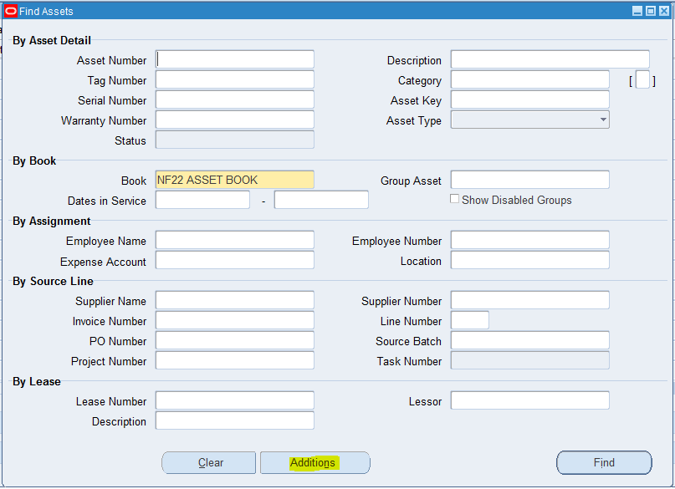
- Enter a Description of the asset.
- Enter the asset Category.
- Enter the India Block of Assets information in DFF.
- Select the Asset Type of the asset.
- Select the actual date of installation information in DFF.
- Enter the number of Units.
- Choose whether to include the asset in physical inventory comparisons. By default, the In Physical Inventory check box is set according to the asset category you specified, but you can override that value here.
- Enter whether the asset is Owned or Leased and New or Used.
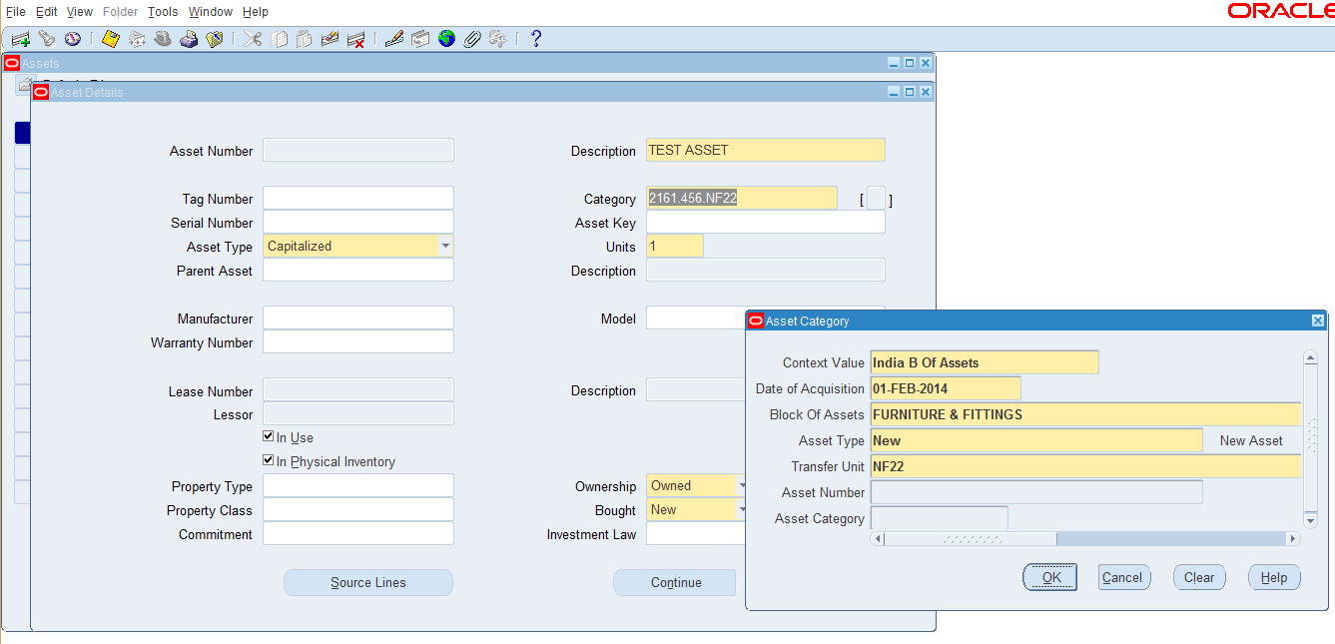
Note:
  - If asset type is taken as ‘New’, no other unit apart from the unit from which the user is logged in could be taken from the DFF.
  - If the asset type is taken as ‘Transferred’, then user can select any other unit apart from his unit. As soon as he selects the Transfer Unit, the field of Asset Number will become editable, and mandatory, and he will have to choose the asset which he is trying to add.
  - Also, as per CR 420, if the asset type is selected as ‘Transferred’, user will have to select the asset number from the LOV. This LOV will be based on the combination of category which user has taken and Transfer Unit which he has selected in the LOV. For instance : If he has selected category as ‘2161.456.HA11’ and , taken transfer unit as ‘WA11’ , all the assets of WA11 and category ‘2161.456.WA11’ will be shown to him in the LOV. User will then have to select an asset, which he is trying to add.
  - This LOV of Asset Number will be containing all the transferred assets (from unit B which are not yet transferred to Unit A) and all non-retired asset of Unit B.
  - The number of units that can be added when user (of Unit B) selects to add a transferred asset will be equal to units that are transferred from Unit A. For instance, if Unit A has transferred only 5 units of Asset X in which total number of units is 15, then user at Unit A will have to add maximum 5 units first. Once he has added these 5 units, rest of the 10 units will also be available for addition.
  - For assets that are not yet transferred from Unit A, at unit B total number of units in that asset will be available for addition. For instance if Asset X with 15 is not yet transferred from Unit A ,then unit B can add any number of units less than 15 , for X Asset.
  - The DPIS of transferred asset, will be either DPIS of asset that is been selected in LOV, or 1st April of current financial year (of Asset Module), whichever later.
  - Unit A will not be able to execute depreciation, if it has not added all the units transferred to itself. An error message will be prompted, if there are any pending additions, user will have to execute the ‘FCI Pre-Depreciation Run Program ’, which will show all the pending additions of type ‘Transferred’.

  - If asset type is taken as ‘OB’, no other unit apart from the unit from which the user is logged in could be taken from the DFF.

As per CR 446, this type has been withdrawn w.e.f 01-Apr-2014, as OB uploading was a onetime process and is already done in FY13-14.

  - User cannot manually enter asset number. It will be system generated.
  - If block of Assets is CIP or ANPU then only Asset category field will be enabled.
  - Block of asset will be dependent on asset category and will be category specific.
  - As per CR 648
- All Assets are having Date of Installation equals to Date of Acquisition at the time of setup of Date of Installation.
- Personalization has been applied on Actual Date of Installations so that it will not allow to enter future date and it has to be less than or equal to the date of acquisition for those with Date of Acquisition on ‘1-APR-2013’.
- Personalization has been applied on Actual Date of Installations and it has to be more than or equal to the date of acquisition for that assets.
- Personalization has been applied which will let you modify DOI for Asset Type 'OB' and it will not allow you to select 'OB' as Asset Type at Asset Additions.

- Optionally choose Source Lines to enter purchasing information such as the Supplier Name for the asset.

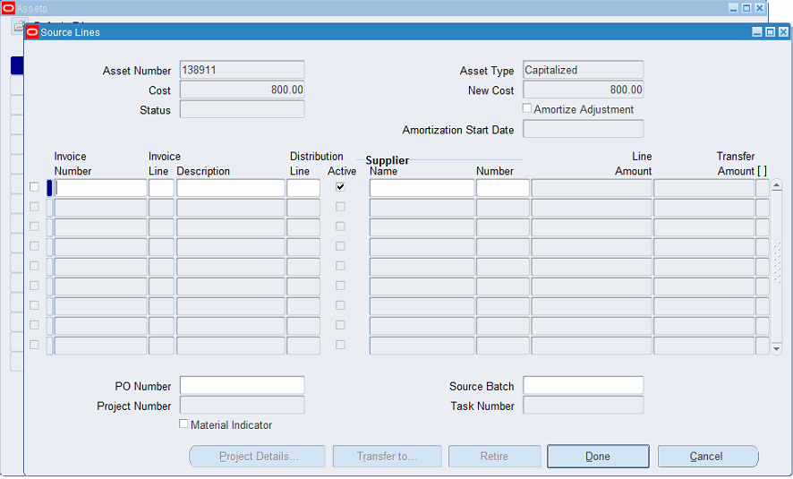

- Choose Continue to continue adding your asset. A check is applied in the system, so that amortization date can be 1st of current financial year or DPIS, whichever later only.

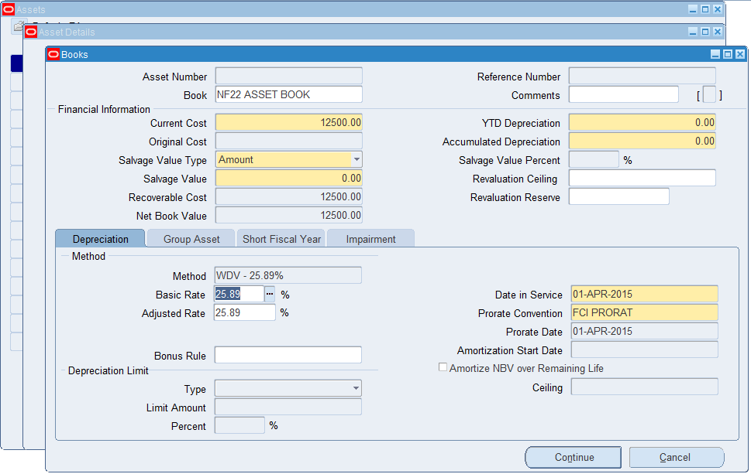

- Assign your asset to a corporate depreciation Book.
- Enter the current Cost for assets which are added as type ‘Transferred’, the user will have to enter the cost and reserve on which the asset was originally transferred , prorated on the basis of number of units added. If user does not enter the correct calculated cost and reserve, and error message will be prompted, showing the cost and reserve to be added.
- As per CR 514 User will not be able to add depreciation reserve in the period of addition for ‘New’ type of assets while for Transferred type of assets user can enter depreciation reserve at the time of addition.
- Also for ‘Transferred’ type of asset Amortization field is mandatory and initial value will be set as DPIS of asset added.
- Salvage value would be defaulted with 0.
To optionally enter or override the depreciation information for a new Asset:
- Specify the date placed in service of the asset.
- Override the prorate convention defaulted from the category if necessary.
- Check the Amortize NBV over Remaining Life check box to amortize an adjustment in the period in which the asset is entered. This check box is available only in the period in which the asset was entered.
- As per CR 420, DPIS of ‘Transferred’, type of asset will be DPIS of old asset (which is getting transferred) or 01st of current financial year whichever later.
- Also as per CR 420, for non-transferred assets, DPIS cannot belong to old financial year.
- Amortize date can be 1st of current financial year, or DPIS of asset, whichever later.
- Choose Continue to continue adding your asset.
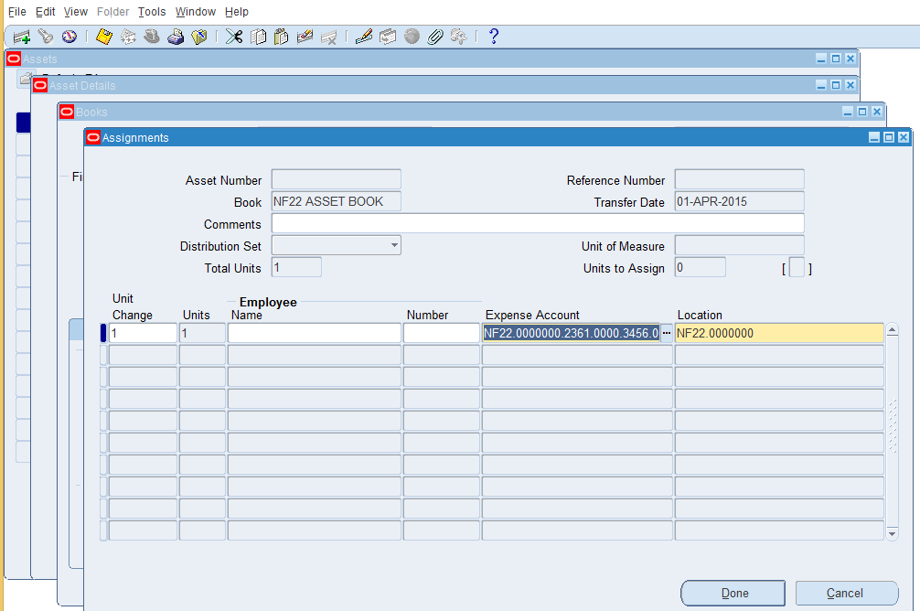

- Optionally enter the Employee Name or Number of the person responsible for the asset.
- Enter the default Expense Account to which you want to charge depreciation. As per CR 443, check has been applied in the system, such that only valid code combination segment of depreciation expense account for major and minor category of assets should be taken up by the system.
For instance, if major category is 2161, and minor category is 456, then in assignments window, the expense account can be 2361, and scheme can be 3456 only.

- Oracle Assets defaults the natural account segment from the category and the book.
- Enter the physical Location of the asset.
- Choose done to save your work.
- System will show you Asset Number and reference number for the transaction saved.

- Run India Income Tax Fixed Asset Schedule Report to see the depreciation values according to Indian Income Tax Act. It has to be done at HQ level.

Note:
- For ‘LAND - LEASE HOLD LAND’ Assets Depreciation method will be WDV - 0% and for every addition in this type of assets user has to manually change the depreciation method through mass change screen.
- In FCI, the life of an asset is generally about 3 years or is too high (about 50-60 years). For assets whose life is high, is not affected by the depreciation calculated as per the current system. (Depreciation calculated on original cost-accumulated depreciation) but for assets whose life is less, is affected. Hence, new STL depreciation methods have been created in the system for 1 month to 36 months.
- New prorate convention of 1 month (FCI MONTH) has been created so that for Assets having per unit value of less or equal to 5000, is completely depreciated in the same FY (if date placed in service of the asset is more than 1st March.)
- System check has been modified such that no depreciation is charged for land (Block of Assets: LAND - FREE HOLD LAND and LAND - LEASE HOLD LAND) even when cost of land is less than or equal to Rs 5000.
- As per CR 456, user cannot take asset type as capitalized for asset category 2193.481.Unit. Also, any other asset category cannot be taken with type CIP while adding an asset.
Note: As per CR 420, asset additions could be done only in the period of February and March.
Note: As per CR 587 if custom period is closed in GL for respective month user cannot make additions in Fixed Assets. An Error Message will be displayed stating the same.
Note: As per CR 674 SB region assets are transferred to SF region in APR16-17 and added on SF in MAY16-17. For this personalization, changes were made for these regions.

CIP Addition

Function Path: Choose Assets > Asset Workbench from the Navigator window.

Steps:
- The type of asset is CIP instead of capitalized .Rest all steps are same as Asset addition.
For CIP select major category as 2193-Asset Capital Work in Progress and minor category as 501- Capital Work in Progress.

Note: As per CR 587 if custom period is closed in GL for respective month user cannot make additions in Fixed Assets. An Error Message will be displayed stating the same.

Capitalize a CIP asset and vice versa
To capitalize a CIP asset, reclassify the asset category from CIP to the required capitalize category.
Refer to section-7-Reclassification for Reclassification

CIP to Capitalize: Whenever any asset is added as ‘CIP’ asset, then it can be capitalized, through ‘Capitalize CIP Assets’ form. But the former condition is, it should be a CIP asset. Following steps need to be followed:
a. Query the asset on ‘Capitalize to CIP’ form, enter book type code, change the type to ‘CIP’, and find all the CIP Assets of that book.
b. Select the check box for assets you need to make capitalize. Click on Capitalize option.
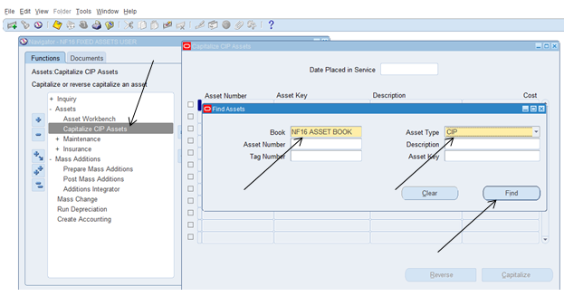

Capitalize to CIP: Only those assets which were added as ‘CIP’ can be reversed from Capitalized to CIP. Normal assets which were added as capitalized type of asset cannot be made as CIP. Following steps need to be followed in case you want to change an asset from Capitalized to CIP:
a. Navigate to ‘Capitalize CIP Assets’ form, insert the book type code, and change the type to Capitalized. System will give you all those assets which were added as CIP, and have been changed to Capitalized.
b. Select the assets you need to again make as CIP, click on reverse options. The asset will be converted to CIP type.
Also, assets from AP, in natural account head 2193, do not come in CIP type of assets.

Note: As per CR 587 if custom period is closed in GL for respective month user cannot make changes like CIP to Capitalize and vice versa in Fixed Assets. An Error Message will be displayed stating the same.

Asset Addition by Excel Upload:
Assets can be uploaded through excel, the format for which has been provided on Home Page.

Navigation Path:

General Ledger Responsibility >> FCI XLS UPLOAD
  - Choose File Type as Asset.
  - Provide the Unit for which Asset has to be uploaded.
  - No. of Columns : Blank
  - Browse the name of the excel for which the file has to be uploaded.

Make sure that the following points are taken care of, so that the excel gets uploaded successfully

- ACCOUNT IS MANDATORY
- COST SHOULD NOT LESS THEN 0
- BLOCK TYPE IS MANDATORY
- DATE OF ACQUISITION IS MANDATORY
- DATE PLACED IN SERVICE IS MANDATORY
- DEPRECIATION COST SHOULD NOT BE NULL
- DEPRECIATION COST SHOULD NOT BE GREATER THAN ASSET COST
- DEPRECIATION COST OR ASSET COST SHOULD NOT BE INVALID
- ASSET DESCRIPTION IS MANDATORY
- LENGTH OF DESCRIPTION SHOULD NOT BE MORE THEN 80 CHAR
- ASSET TYPE IS MANDATORY (CAPITALIZED OR EXPENSED)
- LEASED OR OWNED SHOULD NOT BE NULL
- QUANTITIY OF ASSET CAN NOT BE NULL
- DATE PLACED IN SERVICE SHOULD NOT BE LESS THEN 01-APR-2013
- DATE PLACED IN SERVICE SHOULD BE GREATER THEN DATE OF PURCHASE
- ASSET SHOULD NOT ALREADY EXIST IN SYSTEM.

If the above mentioned points are taken care of, then the asset sheet will get uploaded. To fetch them in the system, user will have to execute FCI ASSET MASTER Request Set, for parameters of the excel which he has uploaded, and asset book.

Mass Additions

- Mass Additions Create
Function Path: FA > Mass Additions > Prepare Mass Additions

Steps: In the Mass Addition Process (Create & Review)
- Create – Enter invoices in Oracle Payables. Run ‘FCI Mass Additions Create’ program through Oracle Payables or fixed asset responsibility.

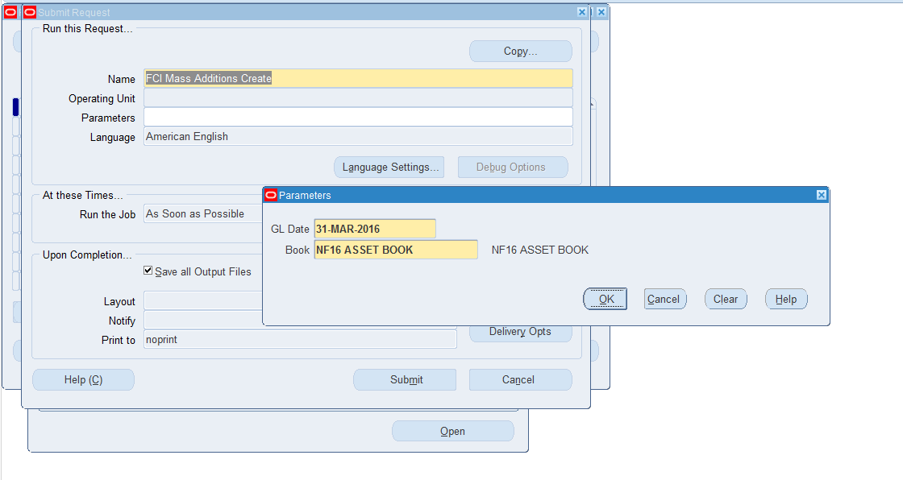
Execute the request for the GL date of the invoice for which asset has to be created in FA and Asset Book will be for the unit used in balancing segment of the distribution line.
- Review – Review mass additions to become assets. Add mass addition lines to existing assets. Split, merge, or adjust mass additions.
- Post – Post your mass additions to Oracle Assets.
- Clean up – Delete unnecessary and posted mass additions. Purge deleted mass addition lines from Oracle Assets.

Note:
- Assets can be created from Accounts Payable also. When any asset account (which is mapped in FA), are used in invoice distribution, then these assets automatically get created in FA. For mapping, kindly refer ‘Asset categories’ sheet in ‘Existing Vs. New A/C Match’ excels.
- Only Standard invoices (No Prepayment/Credit Memo or other category other than STANDARD), with amount greater than zero will be picked for getting transferred to FA.
- Assets added with account head 2193 and scheme 481 in AP, will be added as CIP assets in the system.
- The distribution line in which the line type look up code is ‘ITEM’ will be picked for FA Transfer.
- Discount is not used in FCI; hence, discount part in MASS ADDITIONS CREATE Program is not included.

Function Path: Payables > Invoices >> Enter Invoice from the navigation window.

Steps:
- Enter Invoice (Refer Payable user guide for entering invoices). Use document category of ‘Others’

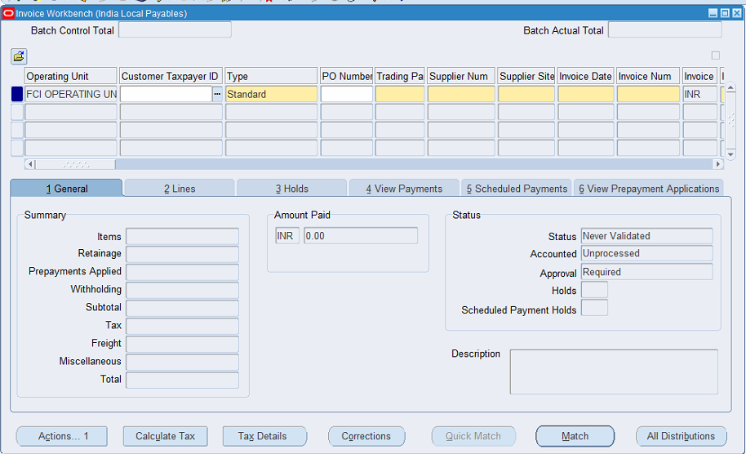

- While entering distribution in distribution lines which are to be created as asset select asset account in Account column.
- Enter two or more lines for creating separate assets.
- Save, validate, approve and run create accounting for Invoice using Actions button available on invoice workbench.
- On successful completion of Journal Import, run ‘FCI Mass Additions Create’ specifying GL date and Corp Book.

Review Mass Addition

Function Path: Choose Mass additions>Prepare mass Additions from the Navigator window.
Note : The Additions as per CR 420 , can be made only in the month February and March.

Steps: To review a mass addition line:

- Choose Mass Additions > Prepare Mass Additions from the Navigator window.
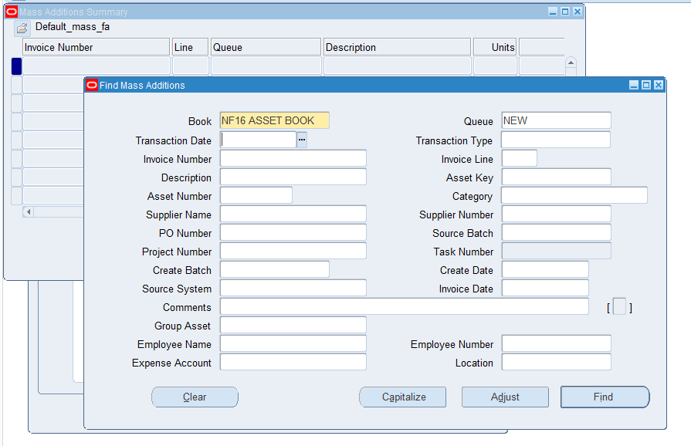

- Find mass additions with the queue name NEW or ON HOLD in the Find Mass Additions window.
Note: If you want to find mass additions by Invoice Number, or Supplier Number, your search criteria must match exactly, including capitalization.
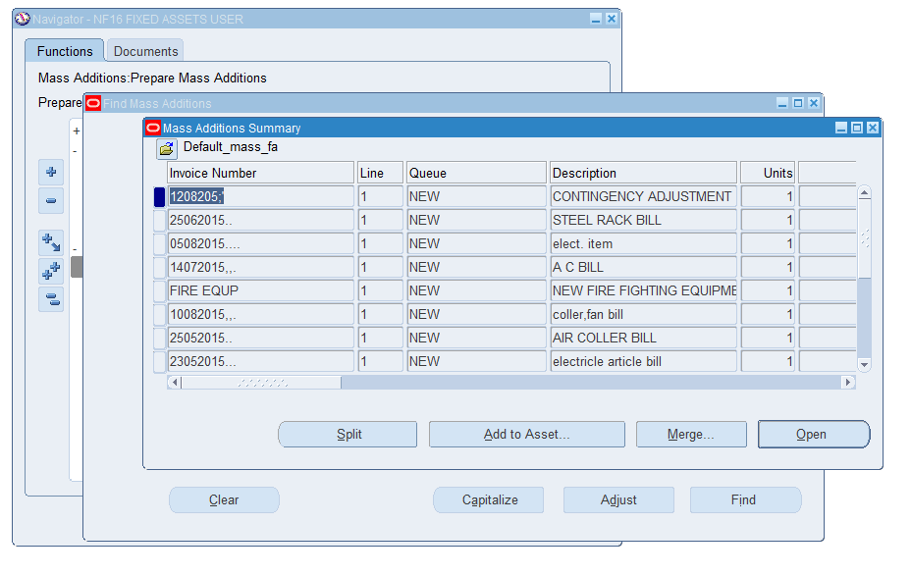

- Choose the mass addition line you want to review, and choose Open.
- Enter Category, depreciation expense account, location and other information. Optionally enter employee name whom asset is assigned.
- Enter the India Block of Assets information in DFF.
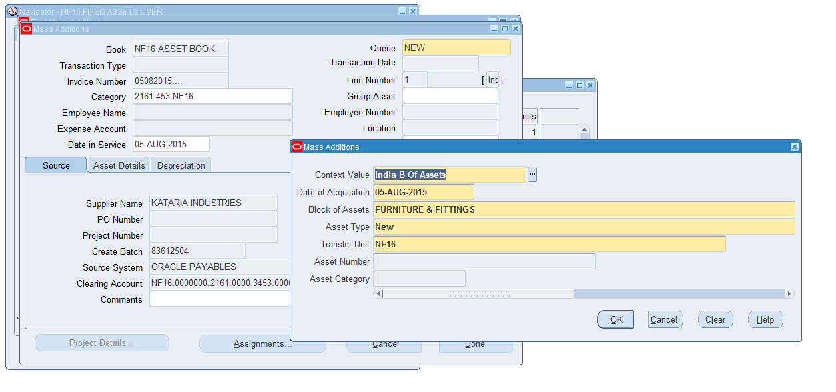
  - Also, as per CR 420, if the asset type is selected as ‘Transferred’, user will have to select the asset number from the LOV. This LOV will be based on the combination of category which user has taken and Transfer Unit which he has selected in the LOV. For instance, if he has selected category as ‘2161.456.HA11’ and, taken transfer unit as ‘WA11’, all the assets of WA11 and category ‘2161.456.WA11’ will be shown to him in the LOV. User will then have to select an asset, which he is trying to add.
  - This LOV of Asset Number will be containing the entire transferred asset (from unit B which are not yet transferred to Unit A) and all non-retired asset of Unit B.
  - The number of units that can be added when user (of Unit B) selects to add a transferred asset will be equal to units that are transferred from Unit A. For instance, if Unit A has transferred only 5 units of Asset X in which total number of units is 15, then user at Unit A will have to add maximum 5 units first. Once he has added these 5 units, rest of the 10 units will also be available for addition.
  - For assets that are not yet transferred from Unit A, at unit B total number of units in that asset will be available for addition. For instance if Asset X with 15 is not yet transferred from Unit A ,then unit B can add any number of units less than 15 , for X Asset.
  - The DPIS of transferred asset, will be either DPIS of asset that is been selected in LOV, or 1st April of current financial year (of Asset Module), whichever later.
  - Unit A will not be able to execute depreciation, if it has not added all the units transferred to itself. An error message will be prompted, if there are any pending additions, user will have to execute the ‘FCI Pre-Depreciation Run Program ’, which will show all the pending additions of type ‘Transferred’.

- Click on Asset Details tab and enter other mandatory Information

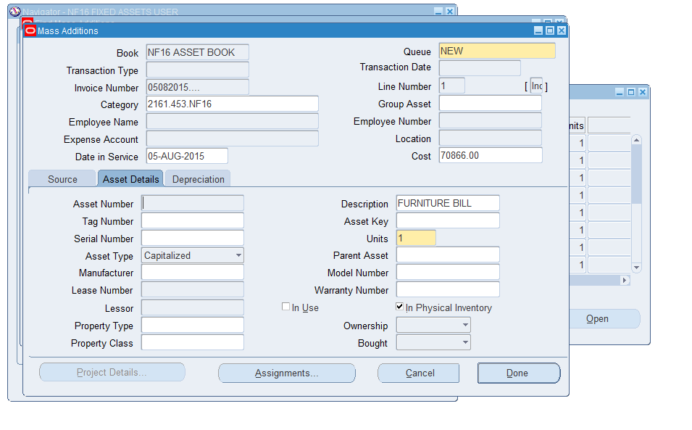

- Change the queue name to POST.
- In depreciation tab, user would be allowed to enter Life in Years and Months in case the selected depreciation method is ‘STL’. All the remaining enterable fields would be frozen as a part of personalization.
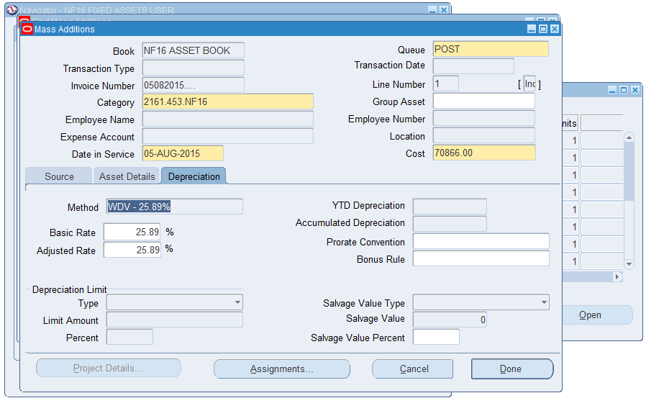
Note: If you are ready to turn a mass addition line into an asset, change the queue name to POST. While you are processing, you can put a mass addition line in the ON HOLD. If you want to delete an unwanted line, assign it to the DELETE queue.
- Save your work.

As per CR 443, check has been applied in the system, such that only valid code combination segment of depreciation expense account for major and minor category of assets should be taken up by the system.
For instance, if major category is 2161, and minor category is 456, then in assignments window, the expense account can be 2361, and scheme can be 3456 only.

As per CR 682, DPIS of the assets which are created through prepare mass addition form should be the GL date of the invoice.

Note: Prepare mass addition form has new tab as depreciation and following personalization are applied on the form –

1) In case of STL Method, Life in Year and Months should be made editable.
2) In case of WDV method, Basic and adjusted rate should also be frozen
3) Salvage value should be frozen with 0 INR.

Add To Asset
Function Path: Choose Mass addition>Prepare Mass addition> Add to existing Asset from the Navigator window.
Note: You can only perform cost adjustments for mass additions in the NEW, ON HOLD, or user–defined hold queues.

Steps:

- Find the mass addition(s) for this transaction in the Find Mass Additions window.
- Choose the mass addition line you want to add to an existing asset as a cost adjustment.
- Choose Add to Asset.
- Query and choose the asset to which to add the line. You can find assets by Asset Detail, Assignment, Source, and Lease.

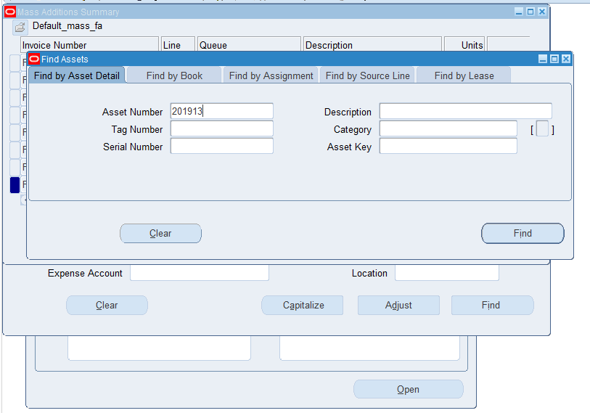

6. Choose whether to amortize or expense the adjustment to the existing asset.
7. Check New Category and Description to change the category and description of the existing asset to those of the mass addition you are adding as a cost adjustment.
Note: After adding to asset, user has to change the queue name to POST for a mass addition line which user is adding to an existing asset, Oracle Assets automatically changes the queue name to COST ADJUSTMENT
8. Save your work.
9. Choose Open and change the queue name to POST.
10. Save your work.

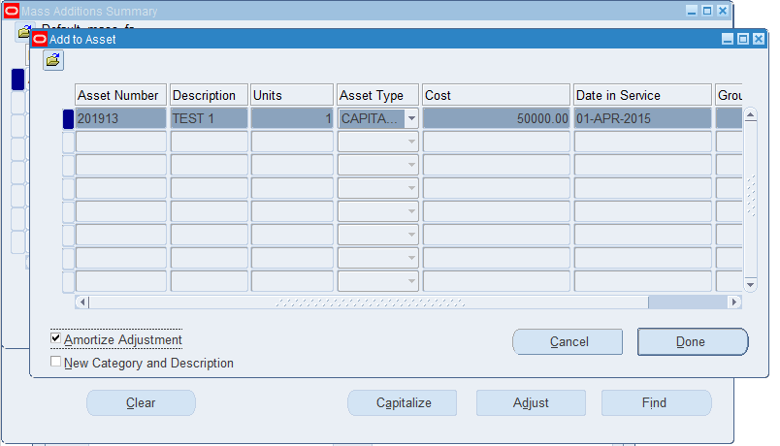

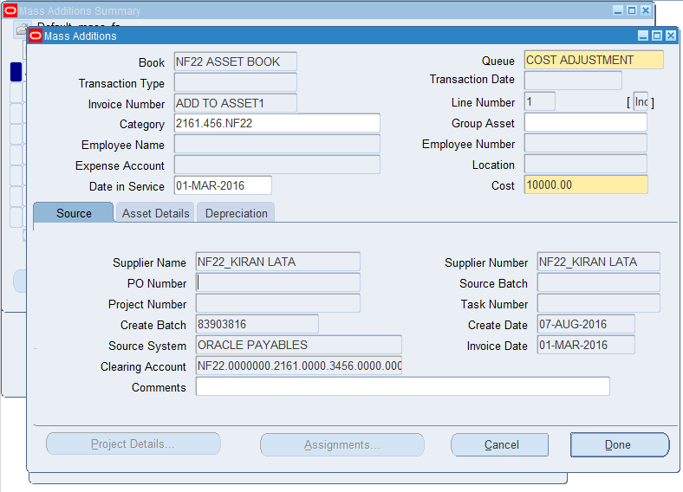

Merge Mass Addition Lines

Function Path: Choose Mass addition>Prepare Mass Addition from the Navigator window.
Note: You can only merge mass additions in the NEW, ON HOLD or POST queues but Merge tab is enabled for NEW, ON HOLD queues.
Invoices from payables and invoices which have same invoice number can be merged.
Steps:
- Find the mass addition(s) for this transaction in the Find Mass Additions window.
- Choose the mass addition line into which you want to merge other lines (the merged parent).
- Choose Merge.
- Choose whether to sum the number of units or keep the original number of units for the line.
- In the Merged Lines block, choose the line(s) you want to merge into the merged parent. If you want to merge all the lines, choose Special, Merge All from the menu.
- Oracle Assets assigns the line(s) to the MERGED queue.
- Save your work.

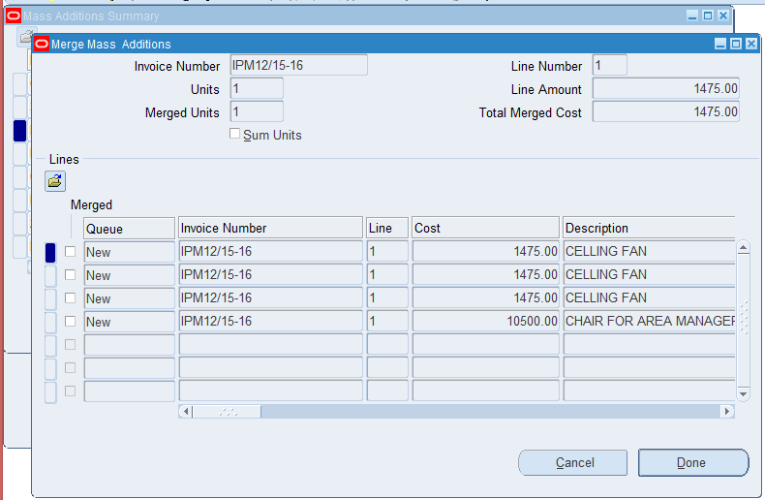

Split Mass Addition

Function Path: Choose Mass Addition>Prepare Mass Addition>Split from the Navigator window.

Steps:

- Find the mass addition(s) for this transaction in the Find Mass Additions window.
- Choose the mass addition line that you want to split.
- Choose Split. Oracle Assets splits the line into multiple single–unit mass addition lines. Review the new lines in the Mass Additions window.
Note: This also splits any merged children on the line, and keeps them merged into the split child.

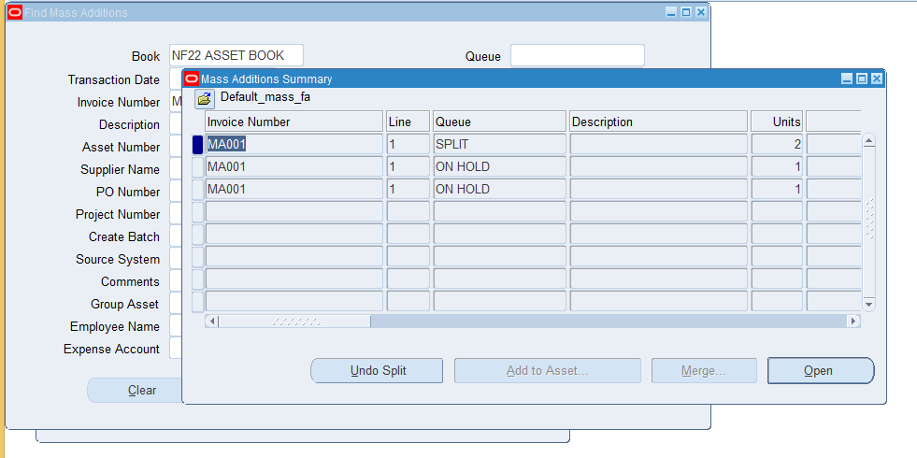

- Click Ok.

Note: Once you set the status to POST, Oracle Assets creates an asset ID, and user can no longer split or merge the mass addition line.
Once the split assets has been Posted, user cannot Undo Split.

As per CR-682 user can update the cost of split assets however total cost of split mass addition lines should be equal to the cost of source invoice line which is split.

Post Mass Additions

Function Path: Choose Mass Additions>Post Mass Additions from the Navigator window.

Steps:
1. In the Parameters window, specify the corporate book for which you want to post your mass additions.

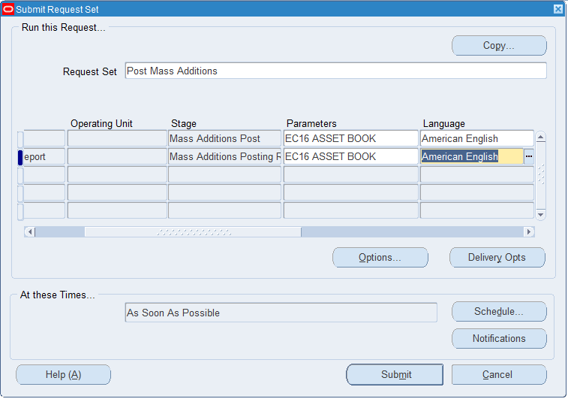

NOTE:
- If you incorrectly added an asset, you can delete it from the system.You can only delete assets added in the current period.
- A check is implemented in system against CR 519 such that asset will not be deleted if journal entry for the asset is present in GL (posted or unposted).
For e.g. If asset ‘A’ is added in MAR14-15 and depreciation is calculated and Create Accounting run to produce Journals then user will not be able to delete the asset. In this case user needs to retire the asset on the same date on which asset was put in use (Date Placed in service).

Establishment Charges /Cost Adjustment
Function Path: Asset Workbench
Steps:
- Choose Asset in which establishment charges to be added.
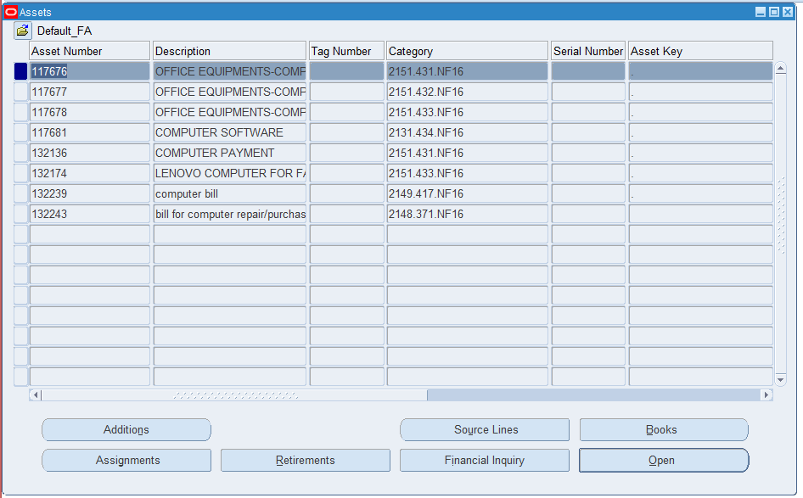

- Click on Book Tab

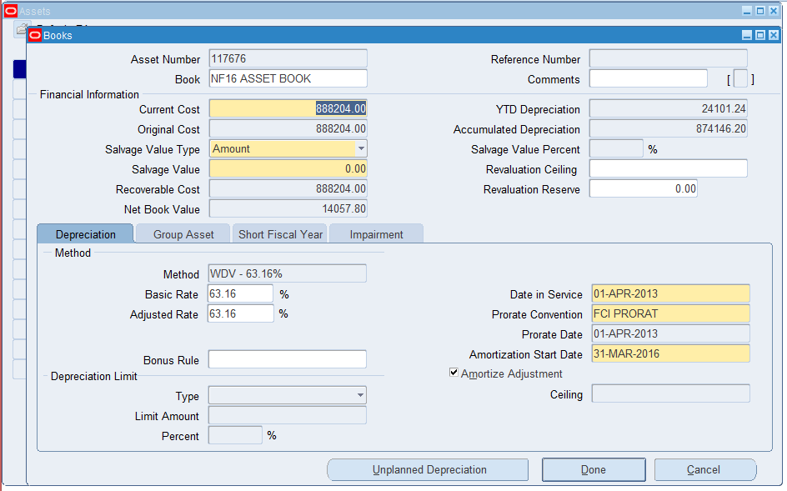

- Update cost of asset with cost of asset + Establishment amount
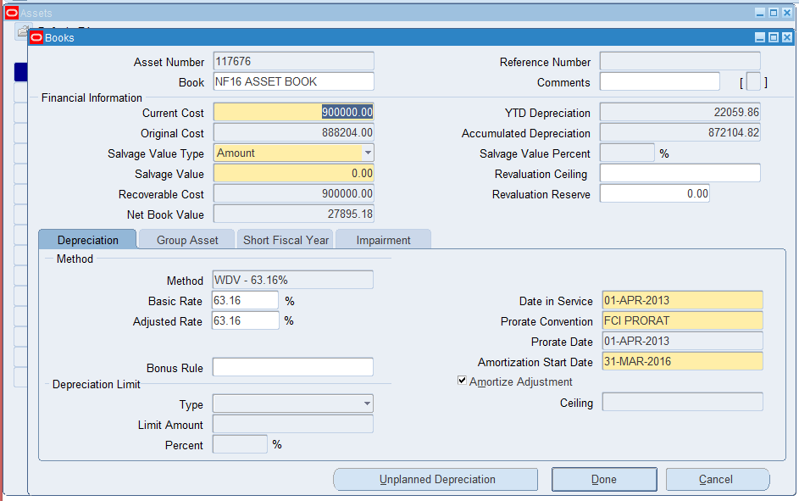

- Click on Save Icon

User has to tick the ‘Amortize Adjustment’ check box and then fill the Amortization Date according to the date from which the change has to be effective.

As per CR 420 , for ‘Transferred’ type of assets , adjustments can be made only when the period in which asset was added gets closed. If the asset is added in Feb13-14 , then no change can be made through Books form , in the period of FEB13-14.

Note: As per CR 587 if custom period is closed in GL for respective month user cannot make adjustments in Fixed Assets. An Error Message will be displayed stating the same.

Note: As per CR 734 Amortization is made mandatory for Adjustments.

Mass Transactions

Transfer
Function Path: Asset Workbench
Steps:
To transfer an asset between employees, expense accounts, and locations:
- Choose Asset to be transferred.
- Click on Assignment.
- Enter negative unit which is to be transferred.

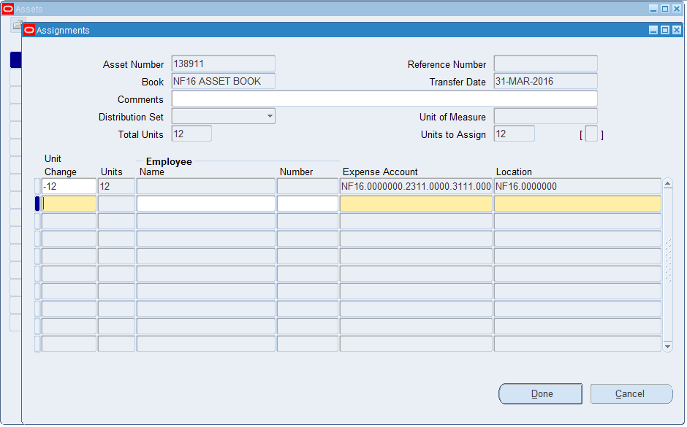

- Enter the Expense account and location (depot) where asset is to be transferred. Click on done to save the transaction.

Note: If you transfer an asset during the period in which it was added, the Transfer Date automatically defaults to the asset’s date placed in service and you cannot change it.
The user cannot select a code combination which is in the process of being closed and will get the error “This code combination is obsolete”.
Also, the user cannot select a code combination which is already closed.

Mass Transfer
Function Path: Choose Mass Transactions >Transfer from the Navigator window.

Steps:
To transfer an asset between employees, expense accounts, and locations (depot):
- Choose Mass Transfer from the Navigator window
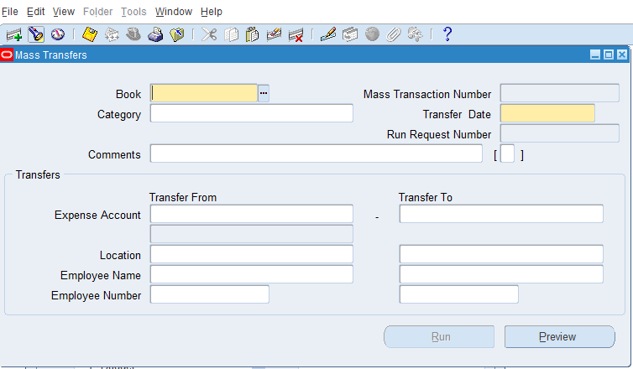

- Give the name of the asset book and category of Asset that you want to transfer.
- Give the from and to expense account, location and employee.

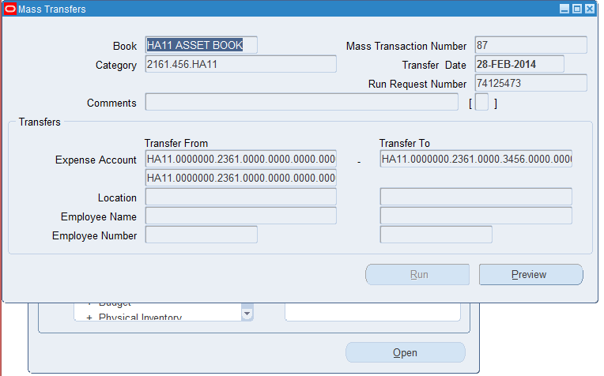

- Optionally update the Transfer Date.
Note: If you transfer an asset during the period in which it was added, the Transfer Date automatically defaults to the asset’s date placed in service and you cannot change it.
Note: The user cannot select a code combination which is in the process of being closed and will get the error “This code combination is obsolete”.
Also, the user cannot select a code combination which is already closed.

- Choose Preview and check the Mass Transfers Preview Report.
- In case, the transfer is correct in Mass Transfers Preview Report, go again to the same Mass Transfers window and query the transaction again with the Mass Transaction window and click Run to give effect to the transfer transaction
- View Mass Transfer Preview Report to view the assets to be transferred.
- Navigate back to Mass Transfer Screen, press F11, enter Mass transaction Number and press Ctrl +F11
- Click on Run to perform Mass Transfer
- Click on Ok On successful completion of process, mass transaction will be in effect.
Note : As per CR 443, the above form of mass transfer has been revoked from normal asset user responsibility.

Reclassification
Reclassification is to be performed in two steps:
- Change Category of the Asset by following below steps:
  - Open Asset Workbench (Asset > Asset Workbench)
  - Querry the asset on which reclass to be done.
  - Click on Open button as shown below.
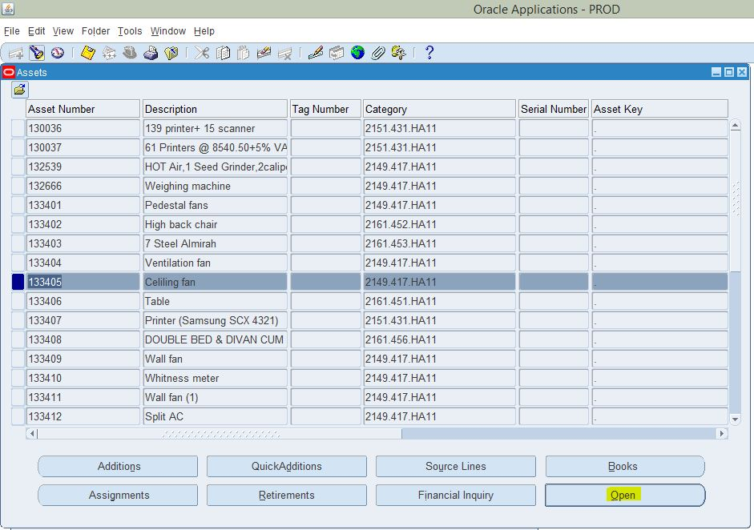
  - Change Category to New/Desired category.
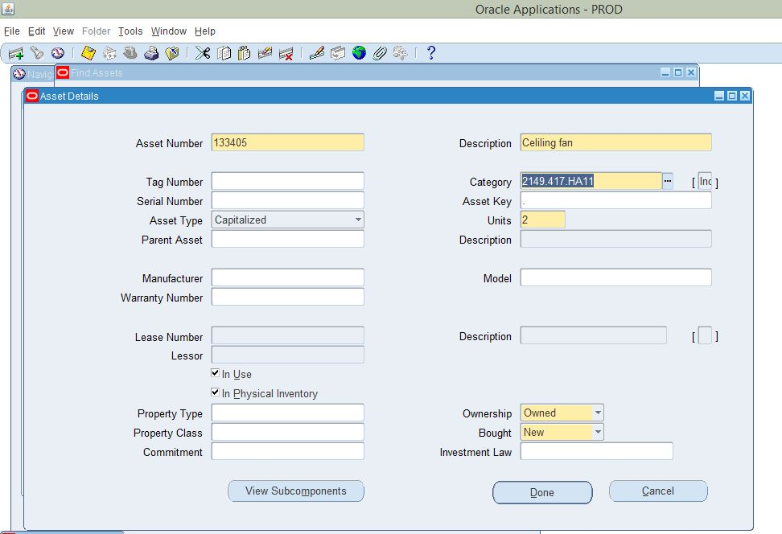
  - Click on DFF to change the Block Type. 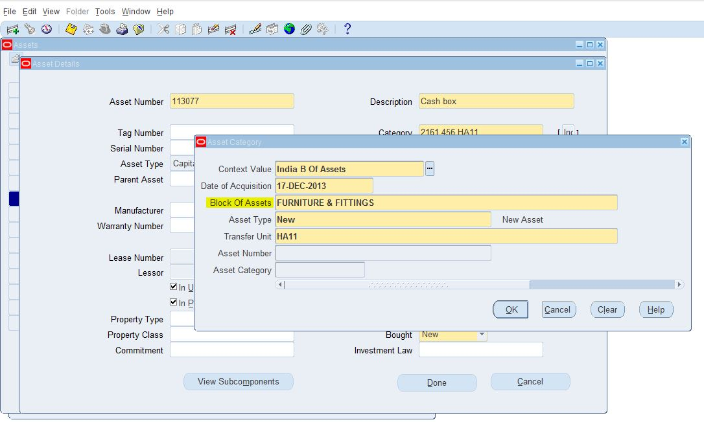
  - Save changes
- Change Depreciation Method of the asset.
2.1 Open Mass Change Form and change the depreciation method as per new category. Also amortise the asset from DPIS or 1st date of Financial Year whichever is later. The detailed process for Mass Change is in point 10 below.
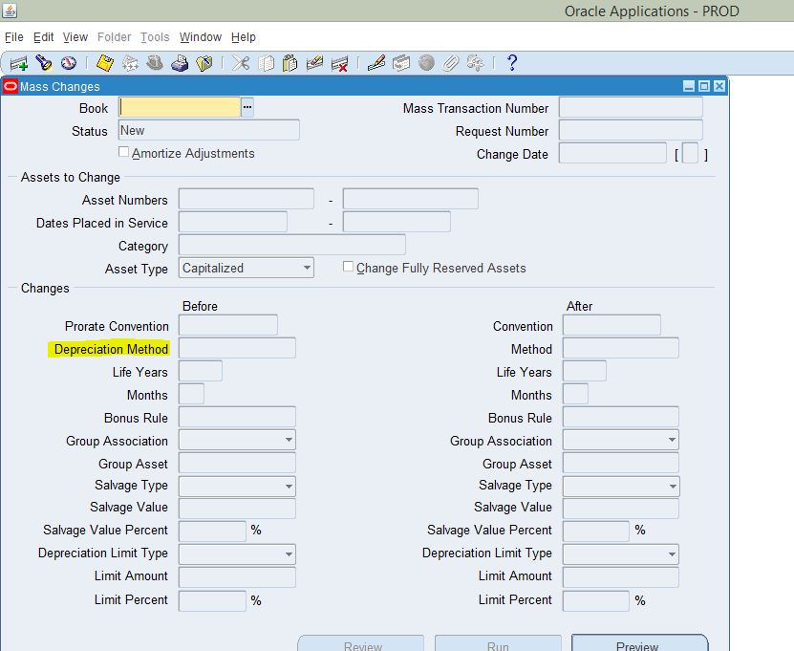

Note : As per CR 456 , the amortization date can be 1st of current financial year or DPIS whichever later when same asset number is entered in From and To Asset number.
When user has not given any 'FROM' and 'TO' Asset Number: In this case, amortization date is 1st of current financial year or not, this will be checked.

When user has given a range of asset numbers: (For example "FROM Asset Number" 108418 to "TO Asset Number" 108423) In this case also, one thing will be checked that whether the amortization date is 1st of current financial year or not.

Note: As per CR 587 if custom period is closed in GL for respective month user cannot change the category/depreciation method in Fixed Assets. An Error Message will be displayed stating the same.

Retirement

Function Path: Choose Assets > Asset Workbench >Retire from the Navigator window.
Note : As per CR 420 , Retirements can be made only in the month of March.

Steps:
To FULLY retire an asset:
- Choose Assets > Asset Workbench from the Navigator window.
- Find the asset you want to retire
- Choose Retirements.

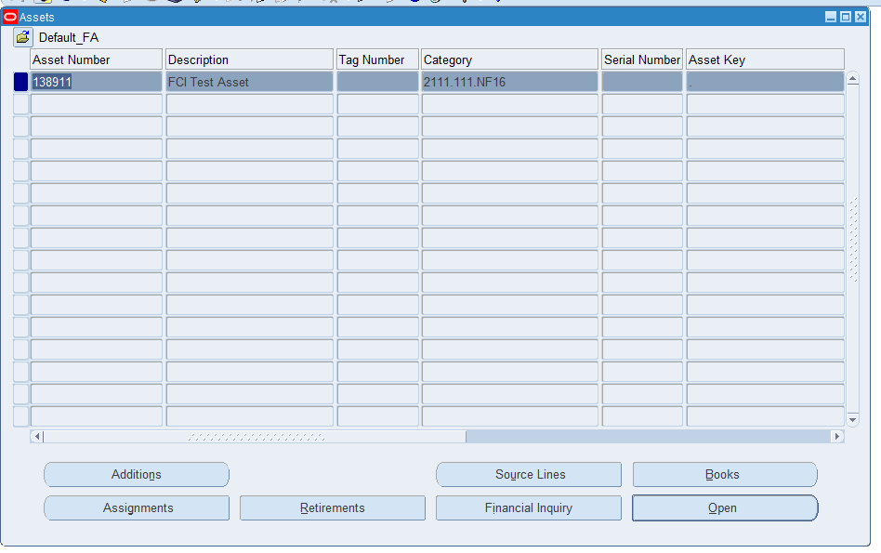

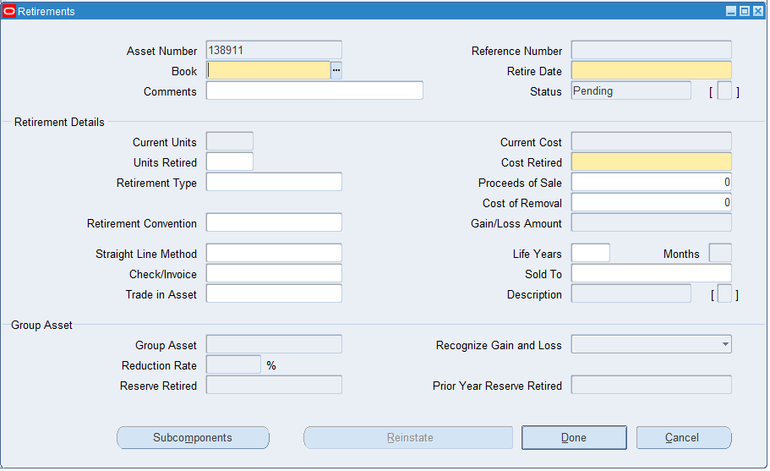

- Select the depreciation Book from which you want to retire the asset.
- Enter the date of the retirement. It must be in the current fiscal year, and cannot be before any other transaction on the asset.
- As per CR 420, retirement date can be 01-Apr of current financial year (of Asset Module), or DPIS whichever later.
- To fully retire the asset, enter all the units or the entire cost.
- Enter the asset Type and unit in the DFF(Otherwise Transfer if asset to be transferred at other unit.)
  - If asset to be retire than select asset type Retired.
  - If asset to be transfer at any other unit than asset type should be transferred. In this case Gain/Loss amount should be zero. If system calculate a non-zero gain /loss than error out depreciation reports. As below screen shot.

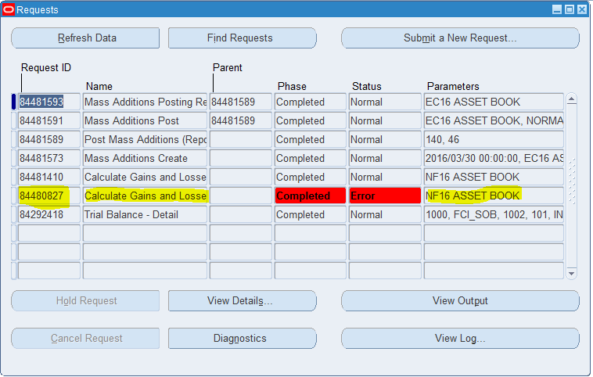

Check view log in this case “ORA-20001: Asset number 138911 with transferred type is having gain /loss of Rs -200 instead of zero amount.”

Adjust the sale amount according to Profit /loss and rerun the depreciation.

As per Cr 693 Calculate Gains and losses program submenu (shown below) has been assigned to all end users responsibilities so user can able to run this program separately.
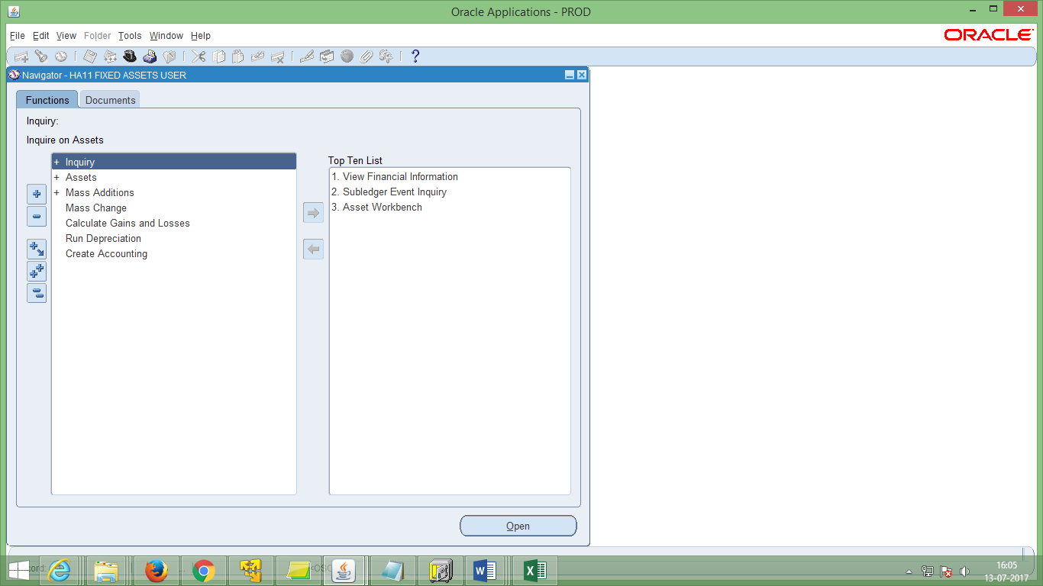

- Save your work.
- Note: Oracle Assets assigns each retirement transaction a unique Reference Number that you can use to track the retirement.
- On Depreciation Run, the status of the retirement transaction will be changed from PENDING to PROCESSED.
- Create accounting entry of selling asset in Accounts receivable module crediting Proceeds of sale account and debiting Cash/Bank account.
- As per CR 456, cost of removal will remain disabled for all type of retirements.

Note: 1.1 if the asset type is retired while retiring the asset, then user cannot take any unit In ‘Transferred Unit’ apart from his unit.
1.2 If the asset type is ‘Transferred’ while retiring an asset, then user cannot take his unit in the Transferred Unit segment.
1.3 No longer forced to delete assets in the period it was added, due to the event
accounting – Oracle treats the addition and retirement as two separate events, so
now Oracle allows assets to be retired in the period added.

User can view retirement transaction from financial inquiry screen also.
- Navigate to Inquiry.

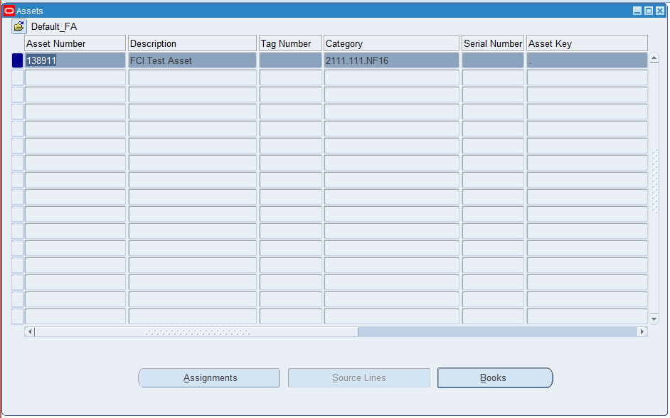

- Click on financial Inquiry screen. Click on Cost history tab
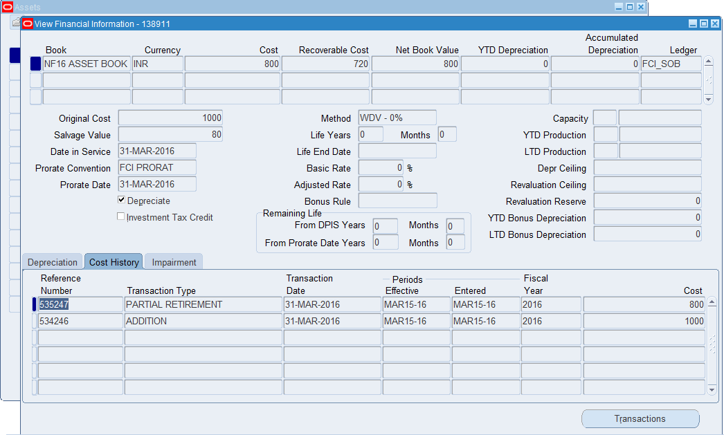

Note: As per CR 587 if custom period is closed in GL for respective month user cannot retire asset in Fixed Assets. An Error Message will be displayed stating the same.
Note: As per CR 761 If HA11 is transferring any asset to any unit (e.g. EA11), that unit's custom period must be open. i.e. EA11 must have custom period open. This check however is needed for MARCH period only.

Reinstating the retired Asset.

- Navigate to Asset Workbench and select the asset you want to reinstate. Click on retirement tab.

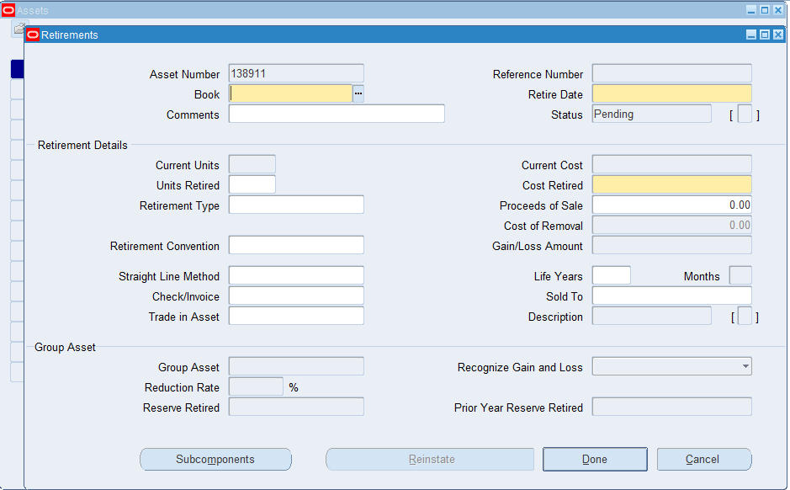

- Press F11

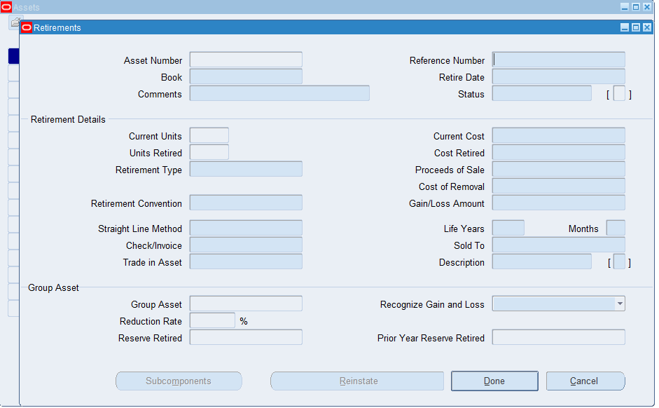

- Enter retirement transaction number in Reference number field.

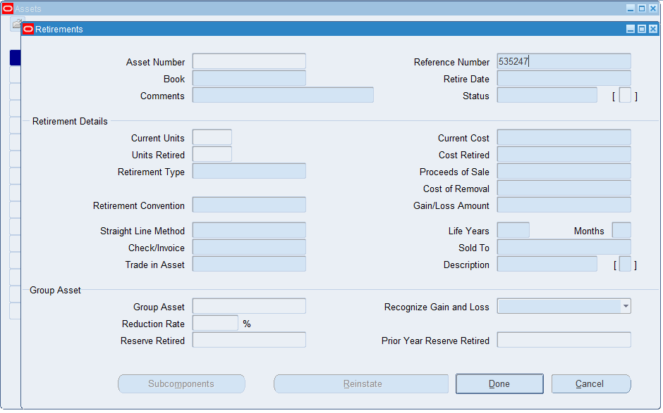

- Press Ctrl + F11
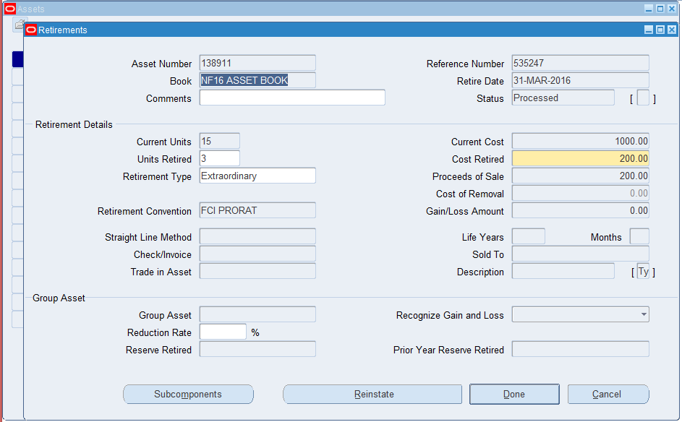

- Click on Reinstate
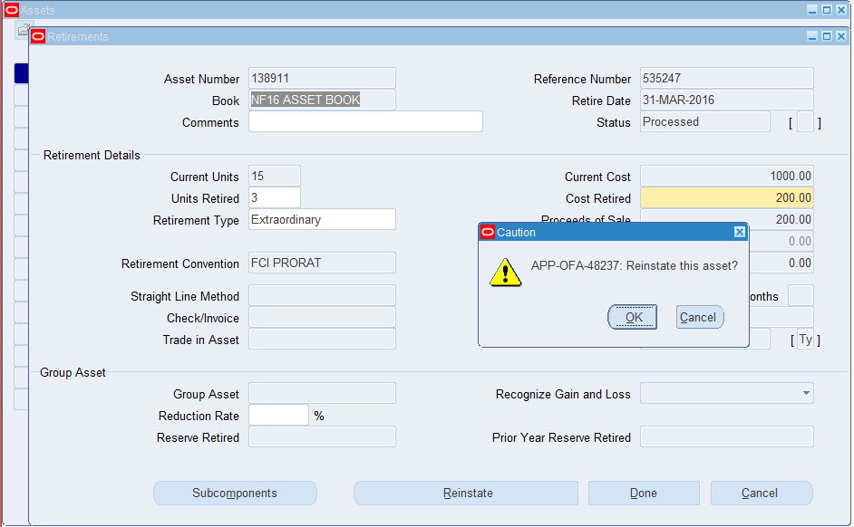

- Click on OK

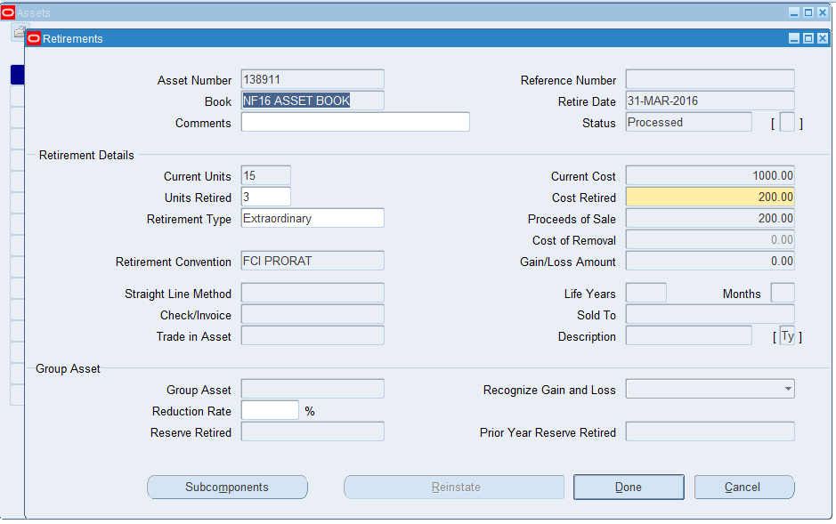

Note: As per CR 587 if custom period is closed in GL for respective month user cannot reinstate asset in Fixed Assets. An Error Message will be displayed stating the same.

Mass Change
Function Path: Choose Mass change from the Navigator window.
Use this functionality to Change financial information for a group of assets.
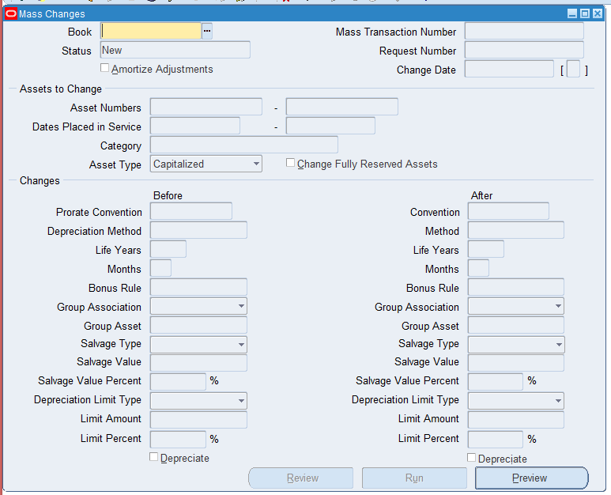

Steps:
- Enter the Book to which the assets belong.
- Select the assets you want to change. Specify the asset numbers, dates placed in service, and category for which the Mass Change applies.
- Choose whether to Change Fully Reserved Assets.
- Specify the new financial information for these assets in the ‘After’ column.
- Choose whether to amortize the adjustment or expense it in the current period.
- Choose Preview to run the Mass Change Preview report. Use this report to preview what effects to expect from the Mass Change before you perform it. If necessary, update the definition and run the preview report again.
- The mass change status determines what action to perform next.
- To review a completed mass change, query the definition and choose Review. Oracle Assets runs the Mass Change Review report.
- Review the log file and report after the request completes.
- As per CR 456 , in case user checks the amortize flag, the amortization date can be 1st of current financial year or DPIS whichever later when same asset number is entered in From and To Asset number.

- When user has not given any 'FROM' and 'TO' Asset Number: In this case, amortization date is 1st of current financial year or not, this will be checked.

- When user has given a range of asset numbers: (For example "FROM Asset Number" 108418 to "TO Asset Number" 108423) In this case also, one thing will be checked that whether the amortization date is 1st of current financial year or not.

Note: Depreciation flag has been disabled as a part of personalization to ensure no changes can be made on depreciation functionality.

Note: As per CR 587 if custom period is closed in GL for respective month user cannot make adjustments in Fixed Assets. An Error Message will be displayed stating the same.

Depreciation

Run Depreciation

Function Path: Choose Run Depreciation from the Navigator window.

Note: The FA period of all the units for March can be closed by Headquarters only. Close period check box will be disabled for all units except Headquarters.

Also, in case there exists data in any of the below categories, user will not be able to run depreciation for his asset book. He will have to first run ‘FCI Asset pre- Depreciation Run Program’, clear the exceptions fetched in this report, and then only he will be allowed to run depreciation.

- If there exists any asset having per unit current cost (current cost /current no. of units) less than or equal to Rs. 5000, and depreciation method not as STL 1- Month. CIP type assets falling in this category will be excluded from the report. Any fully retired assets falling under this category will be excluded from the report. Assets with major category 2111, will be excluded from this category
- If there exists any mismatch in category and depreciation method in any of assets of that asset book (other than STL 1- Month ). Fully retired assets will not be catered in this scenario. CIP type of assets will be excluded from this category.
- Assets having WDV – 100% and having above two issues and not fully depreciated will not be excluded from the exception report.
- If there exists any asset having different minor category and scheme in expense account combination. Fully retired assets of such category will not come in this category.
- Assets which are having Asset Type as ‘CIP’ and category other than ‘2193.481.Unit’.
- Assets which are having asset type as ‘Capitalized’ and category as ‘2193.481.Unit’.
- Fully Depreciated assets will not come in this report in any of the categories.
- If there exists any pending additions of type ‘Transferred’ for this unit. For instance if Unit A has transferred 2 assets to unit B, then unit B cannot run depreciation until and unless it has added these 2 assets.
- If there exists any pending Retirement of type ‘Transferred’ for this unit. For instance, if unit B has added 2 assets, taking Unit A in transfer unit segment of DFF while addition, then Unit A cannot run depreciation until and unless it has transferred these 2 assets to unit B.

Steps:
- Open the Run Depreciation window.
- Choose the Book for which you want to run depreciation.
- Choose whether you want Oracle Assets to close the period after successfully depreciating all assets.
- Choose Run to submit concurrent requests to run the calculate gains and losses, depreciation, and reporting programs.
. 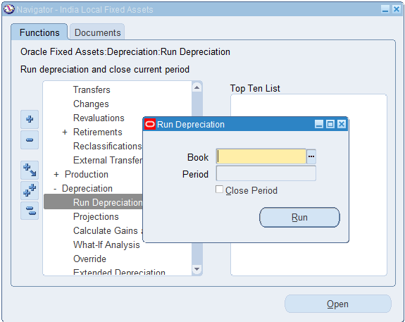

- Review the log files and report after the request completes.
- If the log file lists assets that did not depreciate successfully, correct the errors and re–run depreciation
- View Output of ‘Journal Entry Reserve Ledger Report’ to view the depreciation amount calculated.

Note: As per CR 444 , Run Depreciation menu was revoked from FCI Support User and normal asset user responsibilities temporarily , but as the revised depreciation rates for APR14-15 (as per Companies Act 2013) are updated in the system , the form has been again granted on Site level responsibility as per CR 481.
As per CR 659, March Period Closure was assigned at FCI Support User and revoked once periods are closed.

Note2: As per CR 491, Customization is added in the system to execute India - Income Tax Act Fixed Asset Schedule report when depreciation for MARCH in FA Module with Close Period Check Box Checked is run. Also, this customization will fire ‘Income Tax Act Fixed Asset Schedule report’, with the input parameter ‘Start Date’ as 1st of the FY which is getting closed.

Auto-Roll Back Depreciation
Rollback Depreciation is not a part of R12 release in oracle EBS. This functionality is autocombined with Run Depreciation program and user need not to run this program explicitely.

Once changes have been made to asset, user need to re-run the Run depreciation program and system will re-calculate the depreciation.

Note : This new feature should save time spent rolling back depreciation in order to make corrections.

Create Accounting - Assets

Run Create accounting – Asset program
Function Path: View > Request > Submit a new request > Create Accounting - Assets
Steps:
Enter the Book for which you want to run accounting. Book Type code field would be frozen for entry and would be defaulted for book.
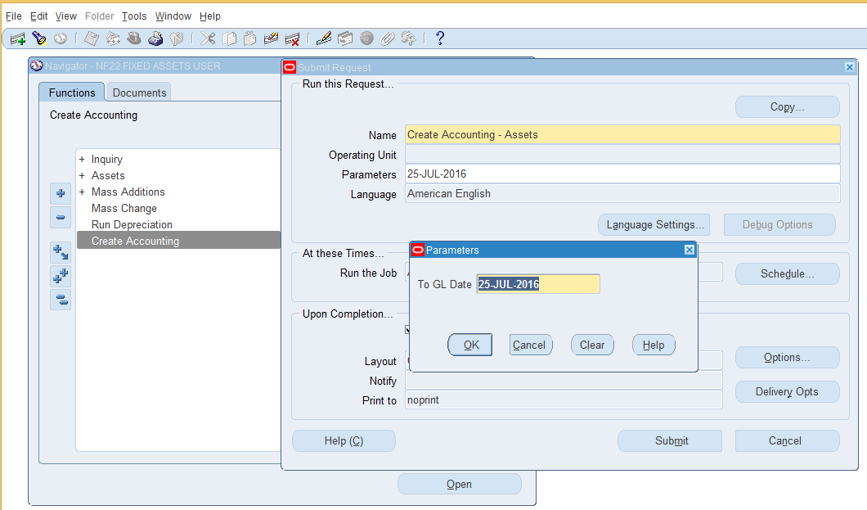

- End Date: The default value for this is the system date. User can change the date. All transactions with an accounting date that is the same or prior to this date will be processed by this program.

Note:
- As there is no concept of Rollback Depreciation in R12, users need not to use Rollback journal entries. System will re-calculate the depreciation and will import the differential entries to GL in posted status using Create accounting – Assets program.
- As per FCI request, only end date field would be available for running Create accounting - Assets program. All other fields would be defaulted with default value. User can find batch name in GL starting with the corresponding unit name.

Post to GL

Function Path: Choose Journals > Enter from the Navigator window.

Steps:
- Switch Responsibility to General Ledger.
- Select Journals>Enter from the navigation Window.
- Enter the source as Assets and / other relevant information to find your batch and Find.
- Review Journal and Post.

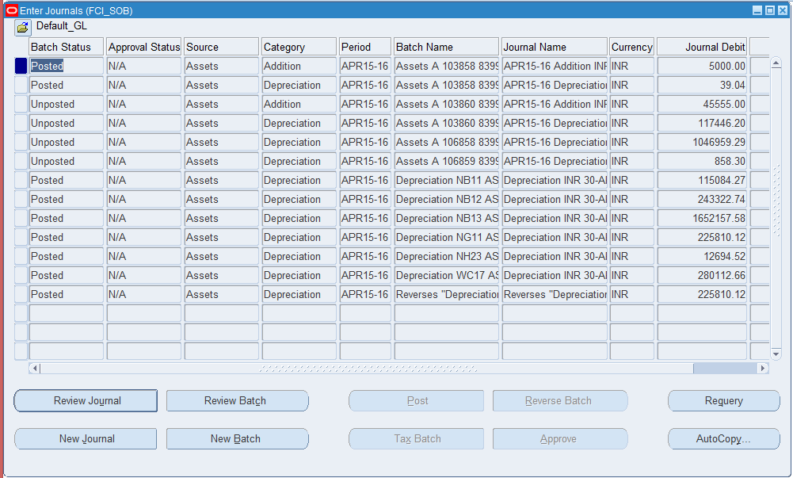

Note: In R12, User would not be able to reverse journals with source ‘Assets’.

Inquiry

Function Path: Choose Inquiry from the Navigator window.

Steps:
To view descriptive and financial information for an asset:
- Choose Inquiry > Financial Information from the Navigator window.
- In the Find Assets window, you can use the tabs to find assets by Asset Detail, Book, Assignment, Source Line, or Lease. You can enter search criteria in one or more tabbed regions.

Find by Asset Detail: Enter asset descriptive information, such as Asset Number, Description, Tag Number, Category, Serial Number, Key Asset, Warranty Number, and Asset Type as your search criteria.
.
Find by Book: Enter book information as your search criteria. If you want to search using the Expense Account in the Find by Assignment tab, you must first enter a Book.

Find by Assignment: Enter assignment information as your search criteria. If you want to search using the Expense Account, you must enter a Book first.

Find by Source Line: Enter source line information, such as Supplier and/or Invoice Number, or project information, such as Project Number and/or Task Number, as your search criteria.

Find by Lease: Enter lease information as your search criteria.

- Choose the Find button to query the asset(s) you want to review. To view the current assignment(s) for an asset, click on the asset you want to review and choose the Assignments button.

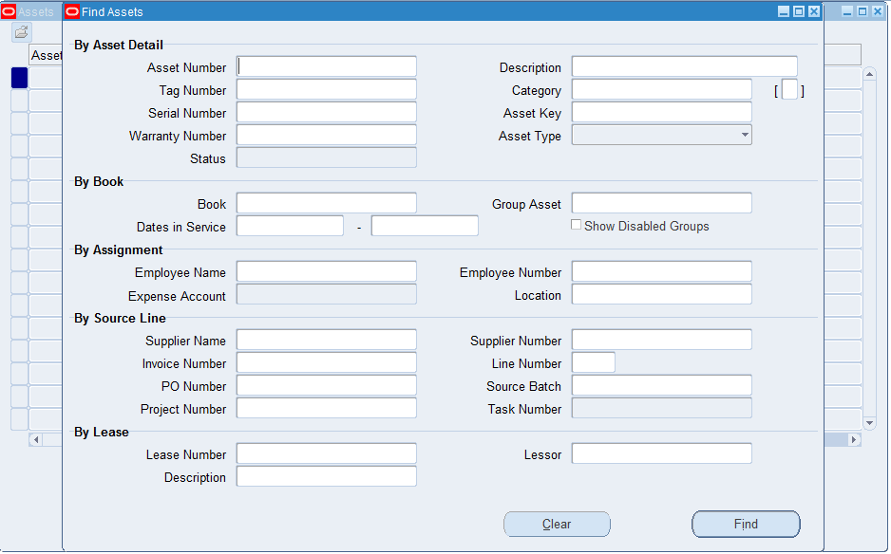

Steps:
To view transaction history for an asset:
- Choose Inquiry > Transaction history from the Navigator window.
Choose Transactions to review transaction history of this asset in the Transaction History window. To view individual transaction details for this asset, check a transaction and choose Details to open the Transaction Detail window.

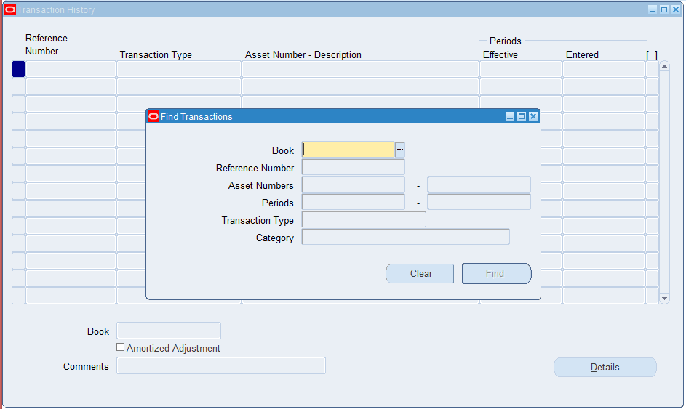

Custom Period Closure

- To maintain the consistency of periods throughout the application” FCI Custom Period Closure Report – Auto invoice & Interface” Report includes following checks also.
  - Check the same period of Fixed Asset module should be depreciation run and transferred to General Ledger before closing custom periods.
  - Distributions eligible to reach to Fixed Assets should be moved to Assets and rest should be marked as not require transferring to Assets.
- The Fixed asset period of all units for March can be closed by FCI Support User only.
- Following Customizations will be applied in Fixed Assets
  - Asset number field will be non-enterable always.
  - Quantity cannot be null or zero on retirement screen.
  - No change in DFF (Asset type, Transferred unit) can be made in the retired asset once it is processed. Incas of reinstate also the DFF will be still freeze.
- Assets up to costs 5000 Rs. Per unit depreciation method should be 100% check will be applied in System. The depreciation method will be STL with 1 Month life span. For asset added between 2 March and 31 March of financial year, user has to manually change the calendar to monthly calendar.
- User will be able to reverse sub-ledger journals (Assets) for FCI ledger, which has lines of his unit only, from normal general ledger responsibility. For instance, if a sub ledger journal contains line of HA11 only, then user can reverse it from HA11 General Ledger User Responsibility, whereas if a journal contains lines of HA11 as well as NA11, then it cannot be reversed by the user.
Note: As per CR 444, point no.a was removed from the report ‘FCI Custom Period Closure Report – Auto invoice & Interface’, temporarily but as the revised depreciation rates (As per Companies Act 2013) are now set up in the system, the report will work as before.

Note: As per CR587, following changes done:
- The depreciation will be checked asset wise and if any data is found message will be thrown in respective column to run depreciation and create accounting.

Note: As per CR 761 Auto Invoice and Interface Report of Custom Period Closure will be modified such that following will suffice:

  - If HA11 is closing Custom period, report must check for pending assets that are transferred by other units but not added on HA11.
  - Similarly, if HA11 is closing Custom period, report must check for assets that are added by other units (type transferred) but not transferred from HA11.

Reports

Asset Category Listing
Description-Use this reports to review all the asset categories.

This report prints the following default information for each category:
• Asset, reserve, and expense accounts
• Depreciation method and life (or adjusted rate plus the bonus rate for flat-rate methods)
• Prorate convention
• Price index name, if any

Parameter Book Name- Enter the book type for the report. Choose the type from the LOV attached.

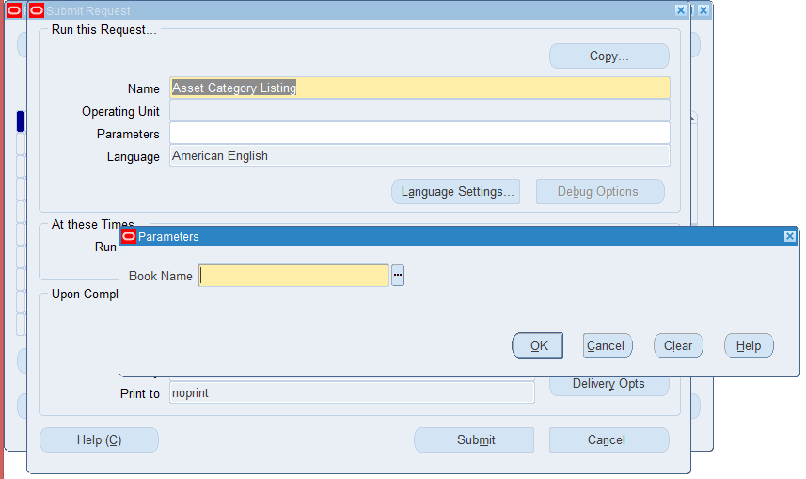

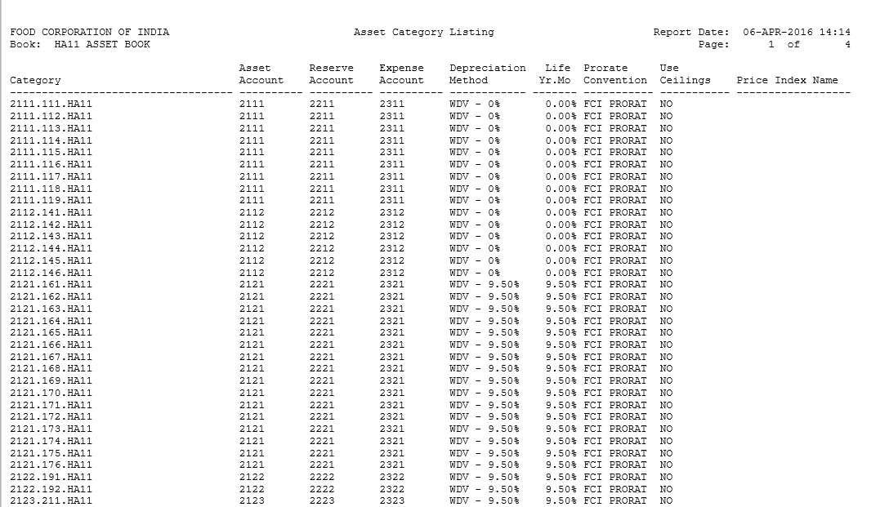

Assets By Category Report
Description- Use the Assets by Category Report to find and review all the assets in an asset category. The assets are sorted by balancing segment and Category in this report. The report prints the total cost for each category and balancing segment.
Parameters:
Book- Enter the book type for the report. Choose the type from the LOV attached.
Note: This report does not display fully retired assets.

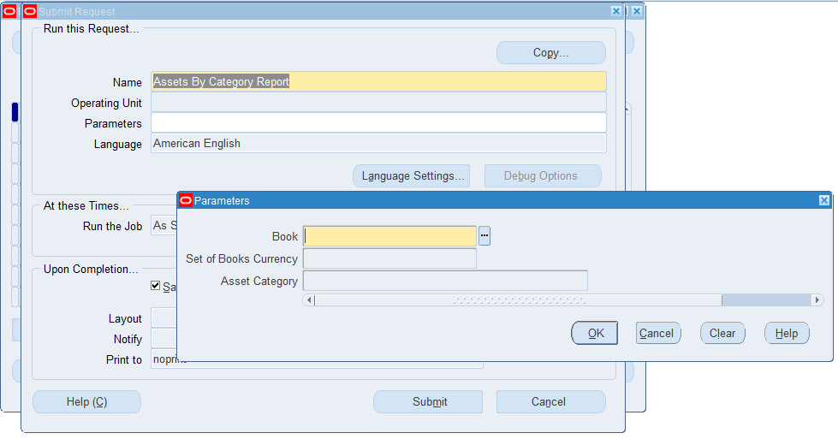

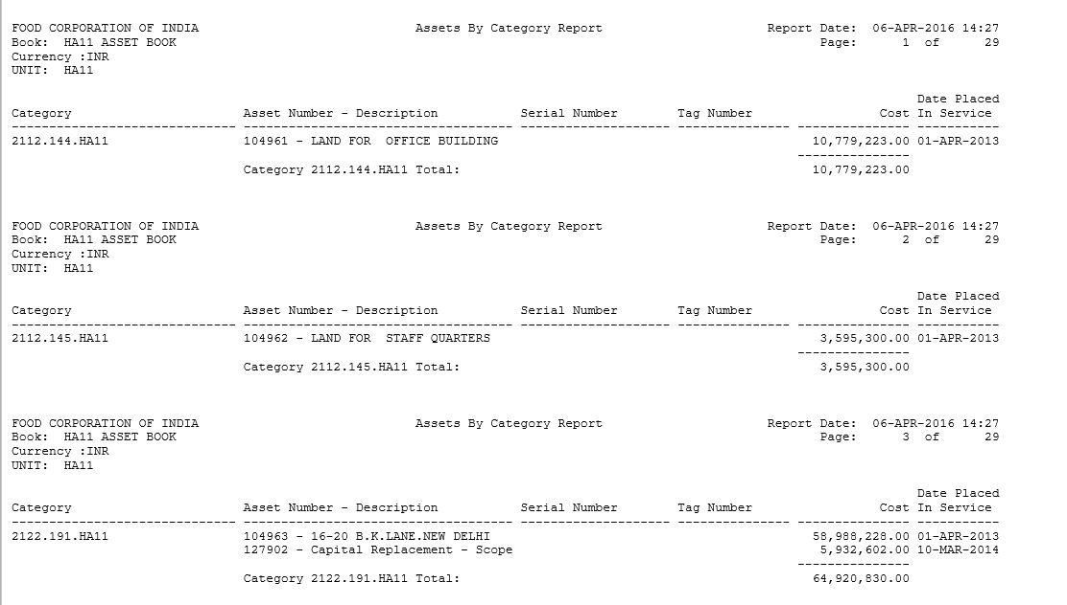

CIP Assets Report
This report shows all the invoice line items and manually entered source line items for your CIP assets. Use this report to review your CIP assets at the end of each accounting period. The report is sorted by balancing segment, CIP cost account, cost center, and asset number. For assets with multiple invoice lines, the report sorts by supplier number, invoice number, and invoice line number. The report prints totals for each asset if the asset has multiple source lines and for each cost center, account, and balancing segment as well.

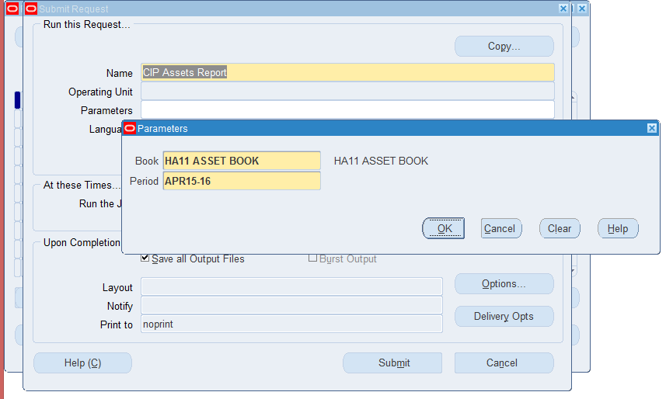

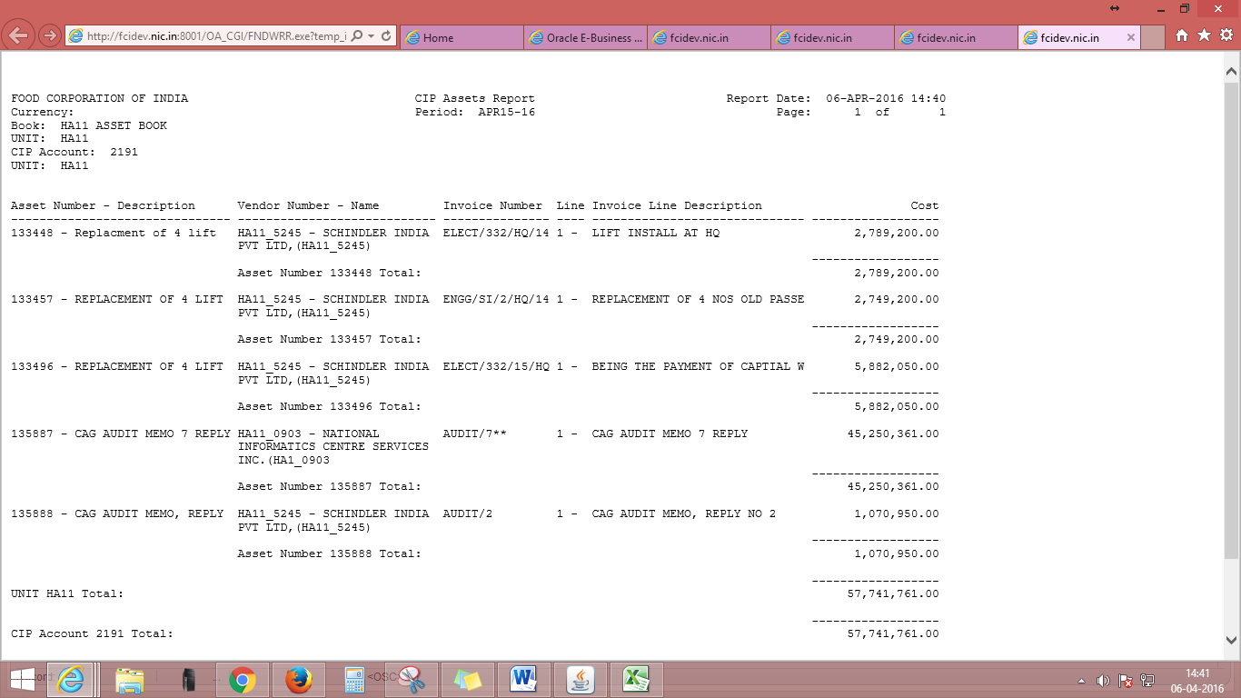

CIP Capitalization Report
This report shows the CIP assets that you capitalized during a range of accounting periods. The report is sorted by balancing segment, CIP cost account, cost center, and asset cost account. It prints totals for asset cost account, cost center, CIP cost account, and balancing segment.

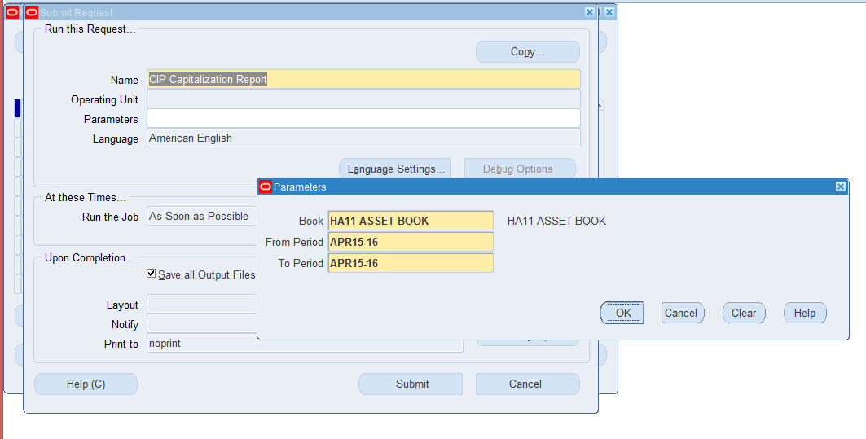

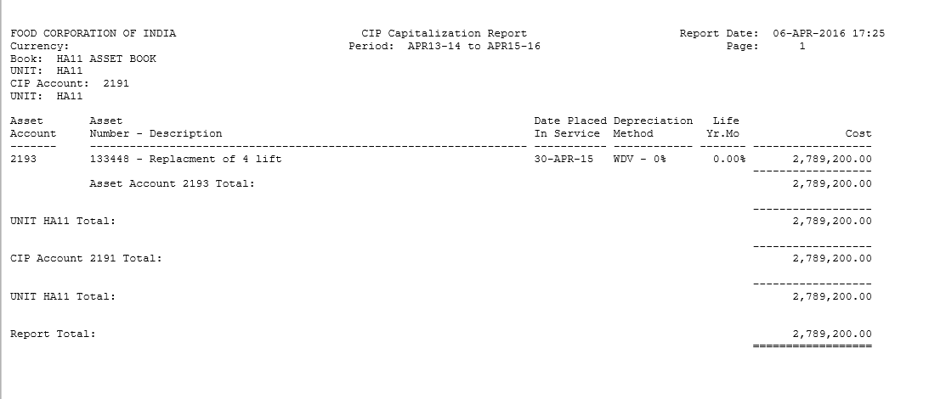

Transactions History Report
Use this report to review all the transactions that you performed on your assets for the Book and Asset Number range you choose. To get additional detail about any of the transactions, use the appropriate transaction reports. The report is sorted by asset number.
Output: Some of the selected headings are:
Reference Number: Uniquely identifies this transaction. This number appears on the transaction reports so that you can find additional detail about the transaction. You can also use the reference number to query the transaction in transaction or inquiry forms.
Accounting Period: The accounting period in which the transaction was effective. To get additional detail about any of the transactions, use this depreciation period when you request one of the transaction reports

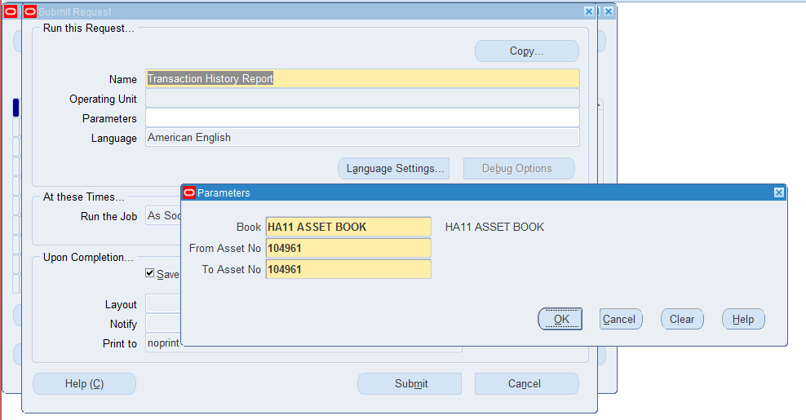

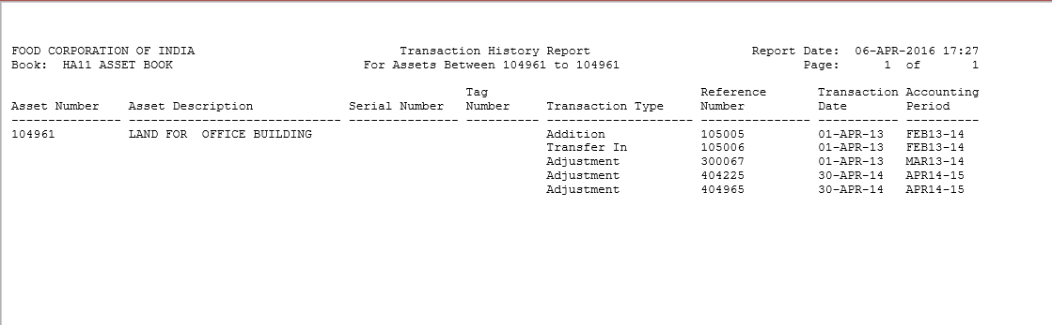

Journal Entry Reserve Ledger Report

Use this report to find out how much depreciation expense Oracle Assets charged to a depreciation expense account for any accounting period. The report lists all active (not yet retired) capitalized assets, as well as any assets that you have retired in the period’s fiscal year. The report is sorted by balancing segment, expense and reserve accounts, and cost center. It prints totals for each cost center, account, and balancing segment.
If you partially retire, reclassify, or transfer an asset, the report prints the asset’s year–to–date depreciation as of the transaction date on a separate line, and marks the line on the right side of the report. These lines show zero for cost and depreciation amount because Oracle Assets allocates depreciation expense only to the distribution lines which were active at the end of the report period.
You can reconcile depreciation expense with your general ledger using this report and the Account Analysis Report in Oracle General Ledger. You must enter a Book and Period when you request this report.
Output:
Depreciation Amount: This column matches the Debit or Credit column of the Account Analysis with Payables Detail Report in Oracle General Ledger.
Year–To–Date Depreciation: The cost center fiscal year–to–date depreciation for the accounting period you select.
Percent: The percentage of the asset cost and depreciation allocated to this general ledger account and cost center.
Flag:
P: partial retirement
F: full retirement
N: asset is not depreciating
T: transfer, either to a new cost center, employee, or location
R: reclassification

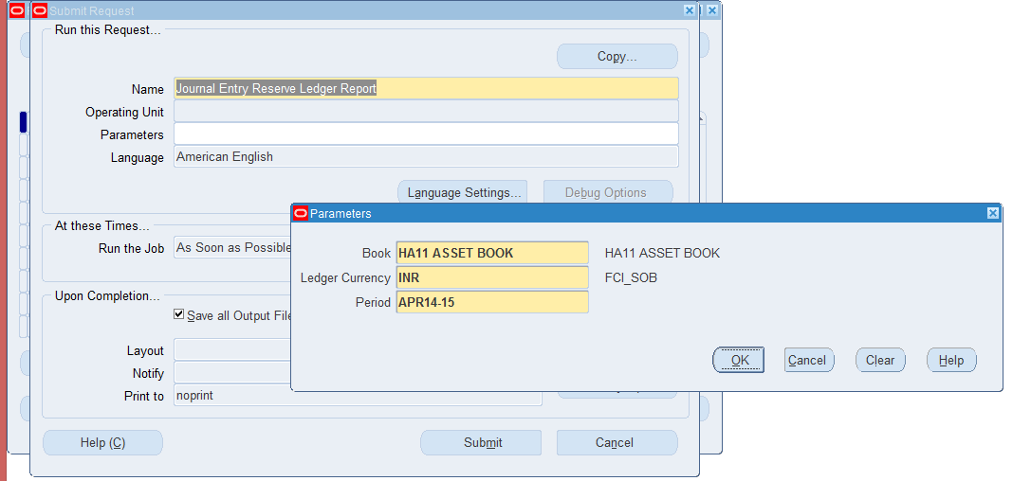

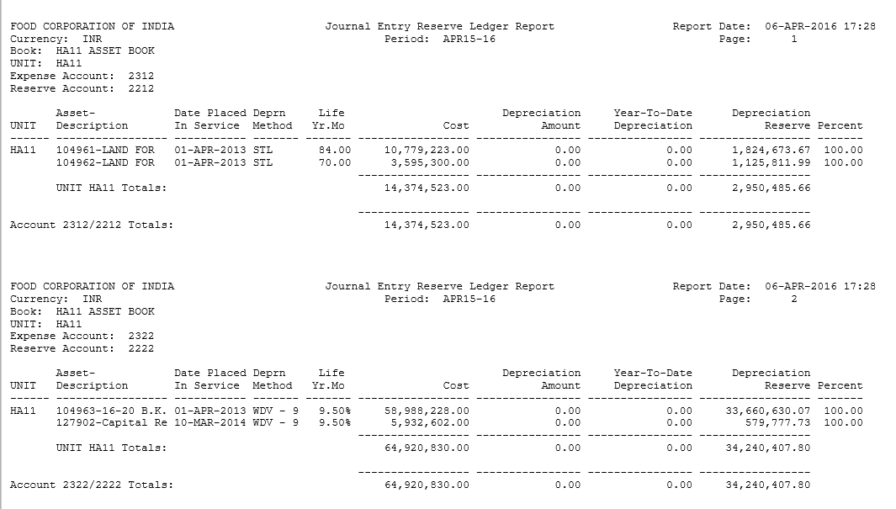

Mass Additions Invoice Merge and Split Reports
Use the Mass Additions Invoice Merge Report to review mass additions that you merged into a single asset. Use the Mass Additions Invoice Split Report to review mass additions that you created by splitting multi-unit mass additions. Both reports are sorted by asset number.

The Mass Additions Invoice Merge and Split reports do not include mass additions added to existing assets. Any mass additions that you merged and then split only appear on the Mass Additions Invoice Split Report. You must enter a Book and Period when you request these reports.
Note: These reports show only split/merge invoice lines that were posted by Post Mass Additions.
Selected Headings
Payable Account: Asset account to which you charged the asset in your accounts payable system.
Assets Account: Asset account for the asset when you posted it to Oracle Assets.
Payables Cost: Asset cost you entered into Oracle Payables.
Fixed Assets Cost: Asset cost when you posted the asset to Oracle Assets.

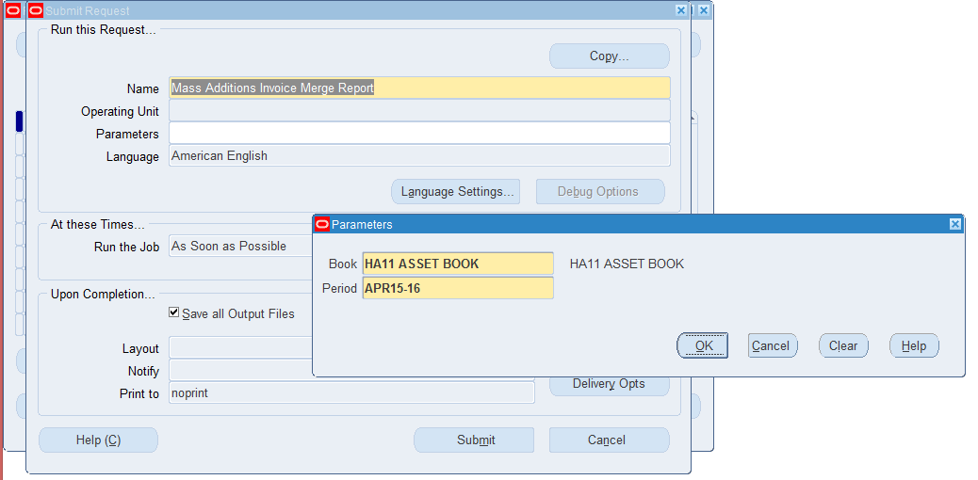

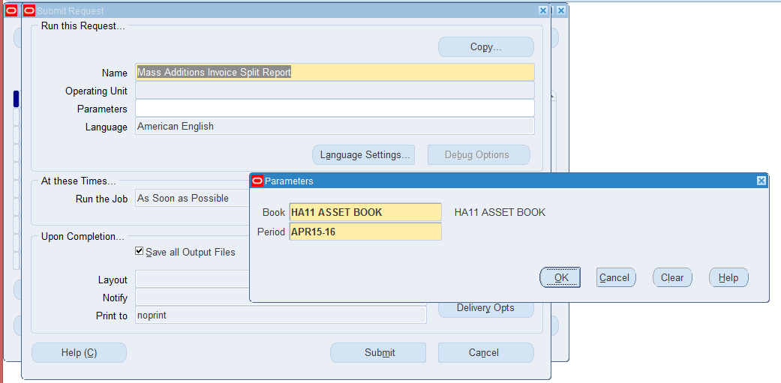

Account Reconciliation Reserve Ledger Report

Description: Use this report to review how much depreciation Oracle assets charged to a depreciation reserve account in an accounting period. The report is sorted by, and prints totals for each balancing segment, asset Account, reserve account, and cost Center. If you partially retire, reclassify, or transfer an asset, the report prints the asset’s year–to–date depreciation as of the transaction date on a separate line and marks each line on the right side of the report. These lines show zero for cost and depreciation amount because Oracle Assets allocates depreciation expense only to the distribution lines which were active at the end of the report period. This report provides supporting detail for the Reserve Detail Report.

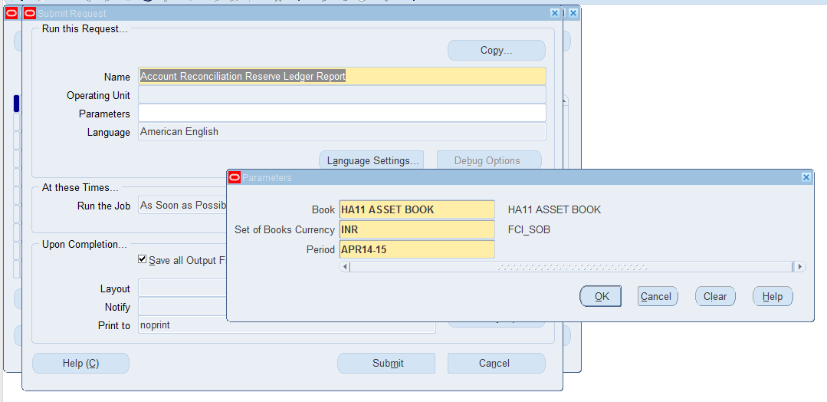

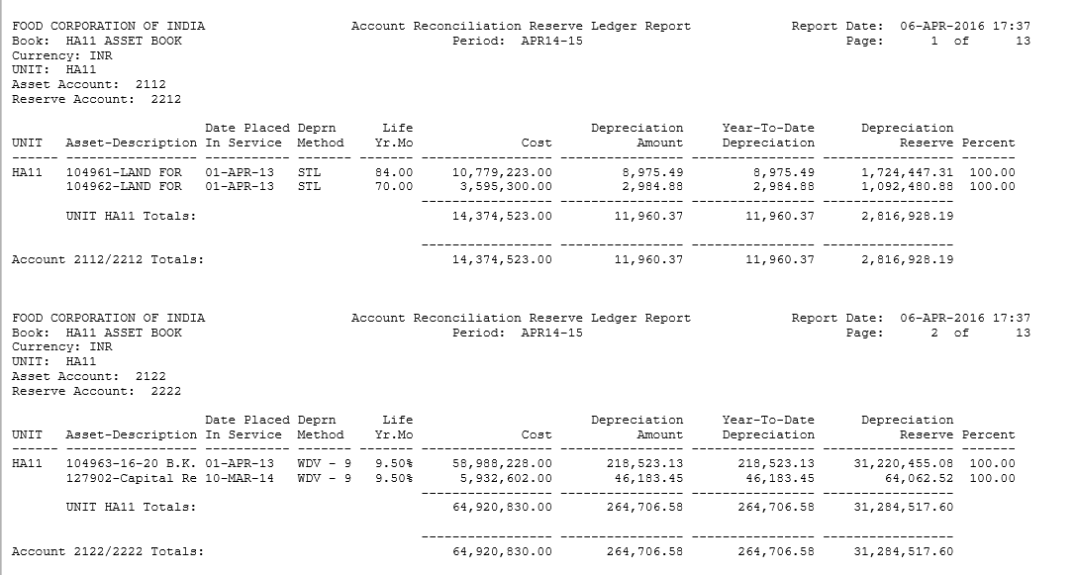

CIP Detail Report

Description:
The CIP Detail reports are used to reconcile your CIP cost accounts to your general
ledger.
The detail reports are sorted by balancing segment, asset or CIP cost
account, cost center, and asset number, and print totals for each asset or
CIP cost center, account, and balancing segment.
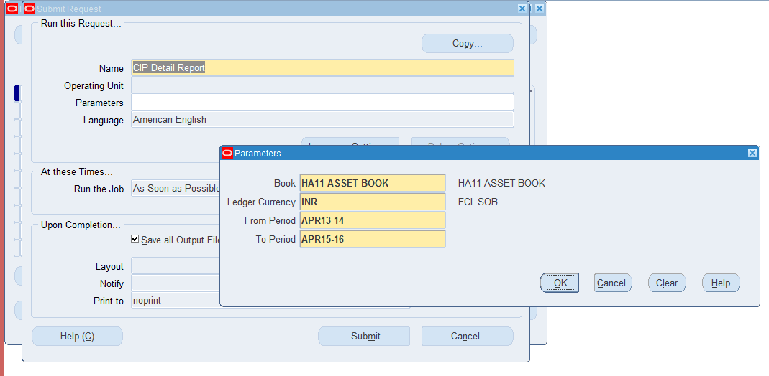

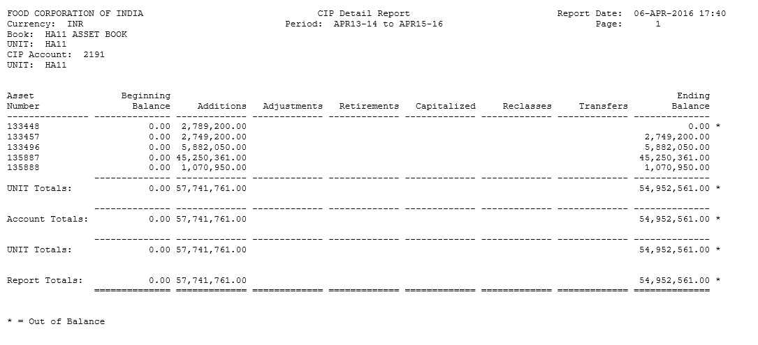

Non–Depreciating Property Report

Description: Use this report to locate property that is not depreciating. For these Assets, you unchecked the Depreciate check box in the Books window.

The report is sorted by, and prints the total cost for each balancing segment, asset type, and asset category. You must enter a Book when you request this report.

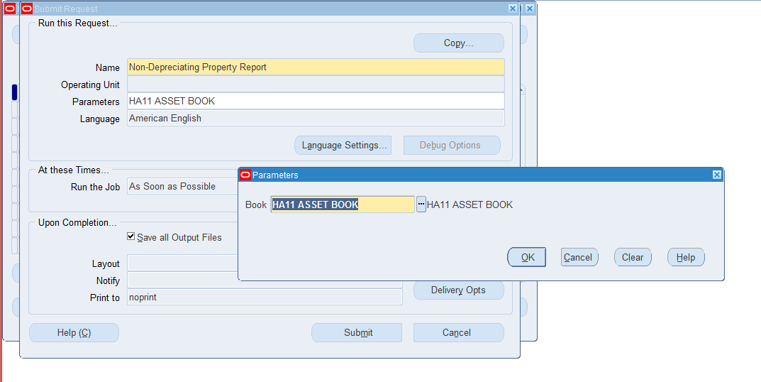

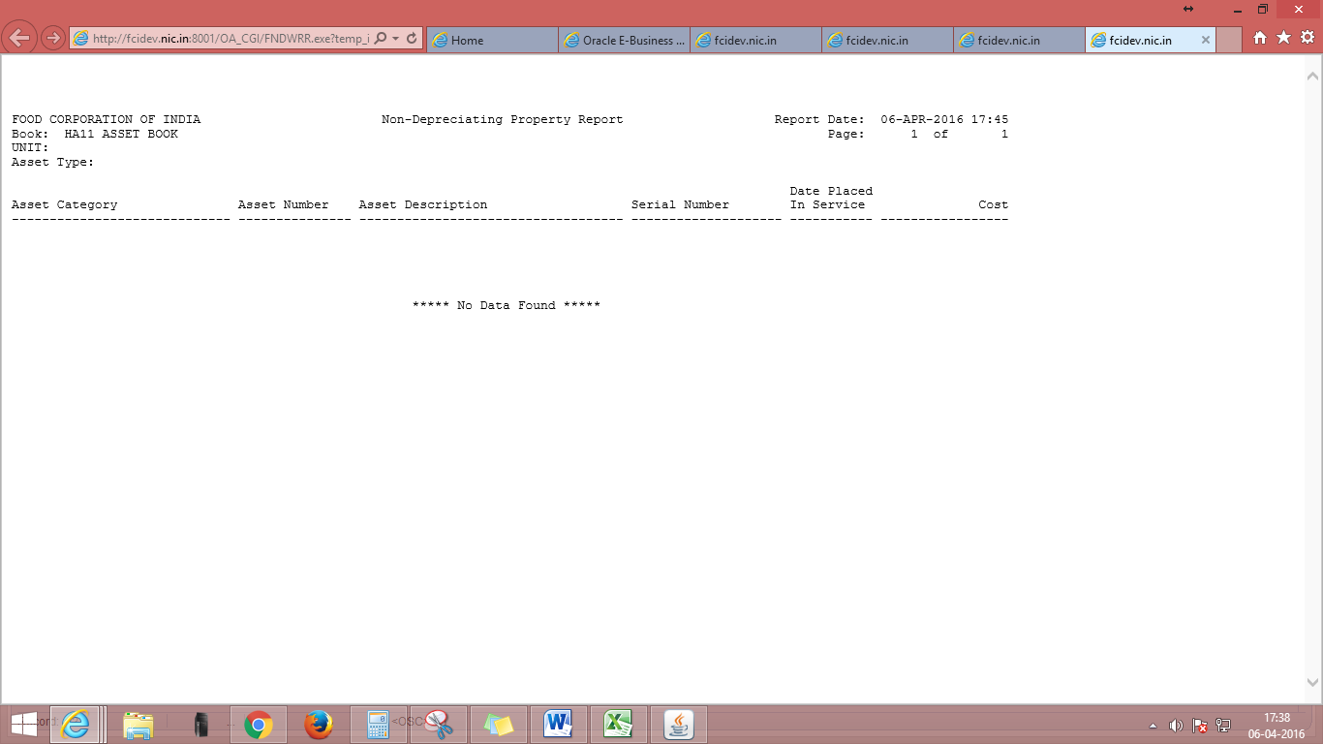

k. Account drill down report

Description:

The Account Drill Down Report give detailed information on the asset transactions represented by a journal entry line. The report is sorted by account (from the lowest balancing segment value to the highest), journal entry batch name, journal entry category, journal entry line number, and asset number. When requesting report enter the Book and Period. If you enter a Batch Name, you must enter a journal entry Line number as well. You can enter the Account Number when you run the Account Drill Down Report, or leave it blank to print all accounts.

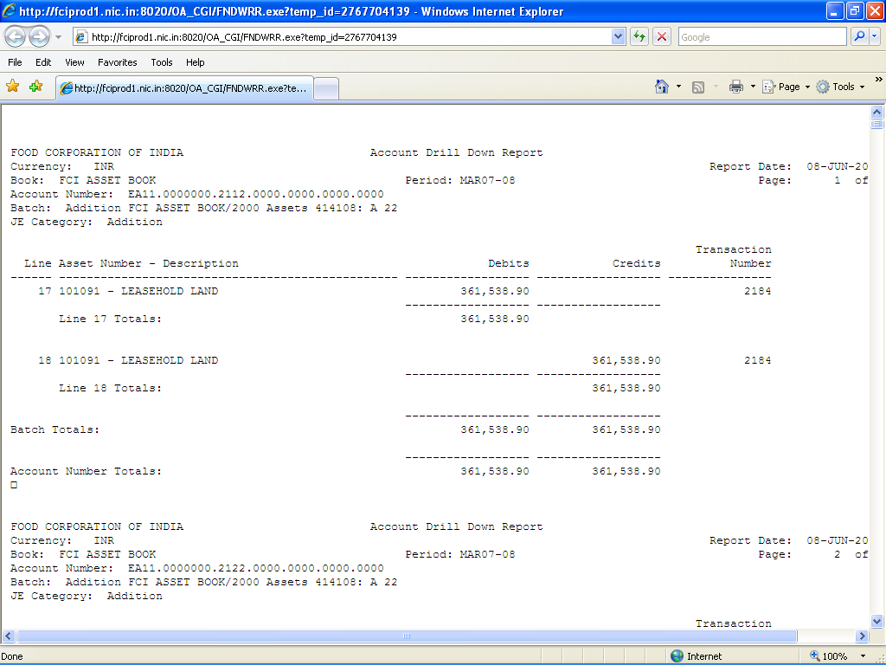

l. India - Depreciation detail report

Description:

Use this report to know the depreciation detail of the assets.
You must enter a Book, Start date, End date and the level of detail when you request this report.

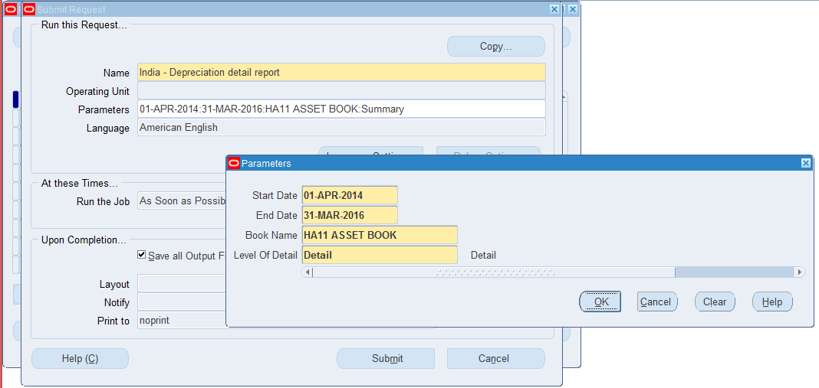

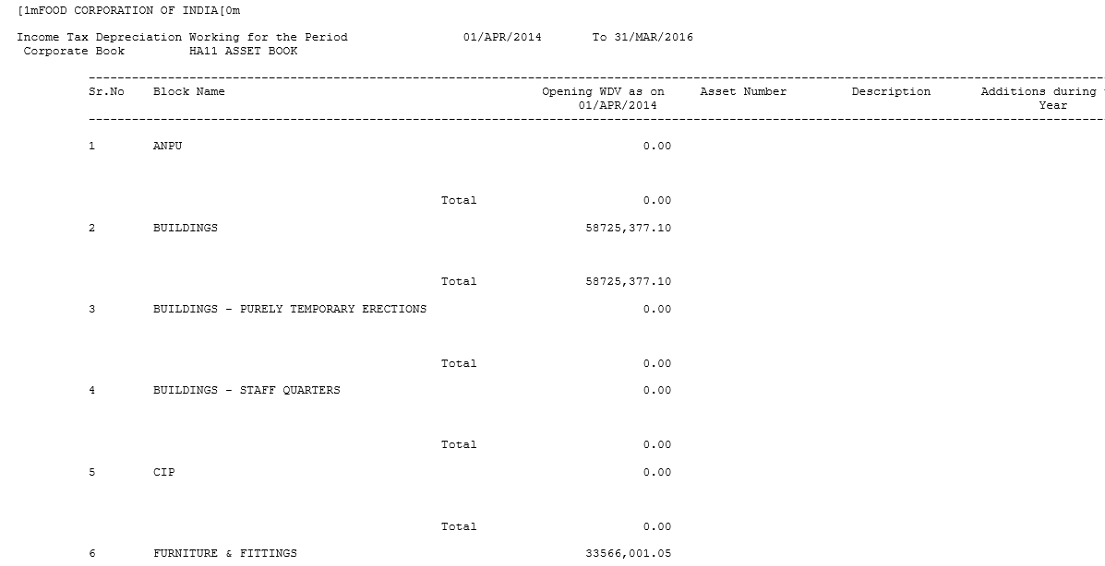

Custom Reports

FCI Assets Retirement Report
This will be an excel report which will fetch the retirement details of any asset.

Input Fields

S.no | Parameter | Optional/Mandatory | Description
1 | Unit | Mandatory | D.O’s can take own unit only. R.O’s, Z.O’s and Hqr can see units under their control or self-unit. Parent Units are also allowed all units assets under parent will be shown in report.
2 | Date From | Mandatory | Consider Date of Retirement this date onwards.
3 | Date To | Mandatory | Consider Date of Retirement till this date.
4 | Asset Retirement Type | Optional | Retired or transferred are the options available.
5 | Asset Account | Optional | Run for all if blank. Major Category of asset category
6 | Minor Category | Optional | Run for all if blank. Minor Category of asset category.
7 | Location | Optional | Run for all if blank. Depots are available as option.
8 | IT Block of Assets | Optional | Run for all if blank. Income Tax blocks are available for selection

Output Fields:
ASSET BOOK: Asset book name starting unit code.

ASSET ACCOUNT: Major Category of asset category.

MINOR CATEGORY: Minor Category of asset category.

IT BLOCK OF ASSET: Income Tax blocks

ASSET RETIREMENT TYPE: Retired or transferred as in Descriptive flex field (DFF) at retirement screen.

TRANSFERRED TO UNIT: Unit taken in DFF at retirement screen.

DATE OF RETIREMENT: Date of Retirement of asset given at Retirement screen.

ASSET NUMBER: Asset number of the asset retired

DESCRIPTION: Description at retirement screen

DATE PLACED IN SERVICE: DATE PLACED IN SERVICE of asset retired.

RETIRED QUANTITY: Quantity retired of the asset at retirement screen.

COST RETIRED: Cost retired from current cost of the asset. Entered by user retire the asset.

DEPRECIATION RESERVE RETIRED: Depreciation reserved due to retirement. Shows after running program calculate Gain/Loss. Difference of Cost retired and WDV retired.

WDV RETIRED: Written Down Value retired of the asset. Or Net Book value retired.

SALES RELISATION: Amount recovered by selling asset retired. Entered by user retire the asset.

REMOVAL COST: Cost to remove the asset from service and FCI premises.
GAIN/LOSS ON RETIREMENT: Net gain or loss to organization after selling the retire asset.
Shows after running program calculate Gain/Loss.
= Sales realization + Depreciation reserve retired - WDV retired – Removal Cost

TRANSACTION NUMBER: Transaction number to retire the asset.

Sub-totals
Subtotal of Sales realization, Depreciation reserve retired, WDV retired, Removal Cost, Gain/Loss on retirement at each change in asset account.

Grand Total
Grand Total of Sales realization, Depreciation reserve retired, WDV retired, Removal Cost, Gain/Loss on retirement at report end.

Order By
Asset account, Asset Book.

FCI Assets Register Report

Input Parameters
S.no | Parameter | Optional/Mandatory | Description
1 | Asset Book | Mandatory | The asset book for which the report has to be executed
2 | Asset Number From | Optional | Run for all if blank (Asset number will be number)
3 | Asset Number To | Optional | Run for all if blank (Asset number will be number)
4 | Active/Inactive | Optional | Run for all if blank.(Fully Retired Asset will be considered as Inactive whereas Partially Retired and new assets will be considered as Active)
5 | Major Category | Optional | Run for all if blank. Major Category of asset category.
6 | Minor Category | Optional | Run for all if blank. Minor Category of asset category.
7 | Assets Type | Optional | Run for all if blank. (Options are Capitalized/CIP).

Note: Page break on each assets number change

Output Fields:

Asset number: Asset Number

Description: Description of the Asset

Location: Depot

Asset Book: Asset book name starting unit code.

Capacity: It will fetch the capacity of the asset.

Date of Acquisition: Date of acquisition of the asset

Tag number: Tag number for the asset

Serial number: Serial number for the asset

Model number: Model number for the asset

Manufacturer: Name of the manufacturer
Property Type: Based on data in Property type field of the asset

Property class: Based on data in Property class field of the asset

Leased/Owned: Leased/Owned based of the data in Bought field of the asset

New or used: New/Used based of the data in Bought field of the asset

In Use: Yes/No based on the In use check box

Parent Assets number: Number of parent asset if asset is attached to parent asset

Parent Assets description: Description of parent asset if asset is attached to parent asset

Asset type: (Capitalized/WIP): Type of the asset

IT Block of Assets: Income Tax blocks

Major Category: Major category of the asset

Minor Category: Minor category of the asset

Salvage value: Current salvage value of the asset
Note: Field will show 0 if no data is present for the asset.
The above mentioned 22 output fields will be displayed in two tables each of 11 columns as:

Asset Number | Description | Location | Asset Book

Date: This will fetch the transaction date

OB: If asset type is ‘OB’ then data will be fetched in this field otherwise it will be N/A

For ‘OB’ type asset:
Qty: If will be original quantity (units) of the asset
Cost: It will be the original cost of the asset
Depreciation reserve: If at the time of asset addition Depreciation amount was reserved then data will be fetched.

Note: For the year in which asset was added, data will be fetch in ‘OB’ only if asset type is ‘OB”. In subsequent years it shall be the closing balance of the previous year.

Note: As per discussion with GM(FAP),the OB data will be displayed under Addition Column, thus the fields under OB column will be removed.

Addition: If asset type is ‘New’ or ‘Transferred’ then data will be fetched in this field otherwise it will be N/A.
Data will be fetched, even if cost has been adjusted for the asset.
Qty: If will be original quantity (units) of the asset (This column will be added for Addition).
For cost adjustment the field will be null.
Cost: It will be the original cost of the asset
For cost adjustment, the cost that has been adjusted will be fetched.
Depreciation reserve: If at the time of asset addition Depreciation amount was reserved then data will be fetched.

Sales: If asset has been Retired (Partially or Fully) then data will be fetched in this field otherwise it will be N/A
Qty: If will be quantity (units) of the asset that has been retired(This column will be added for Addition)
Cost: It will be the cost retired of the asset
Depreciation reserve: This field will fetch the difference between cost retired and NBV retired.
Sales realization: It will fetch the data of proceeds of Sale field.

Profit or Loss on sale: It will fetch the data of gain/Loss amount field
Depreciation during the year: It will show the sum of depreciation for the year. The date for the depreciation will be the last date of the period for which depreciation has been executed for that Financial Year.
Closing Balance: Data will be calculated based on the calculation mentioned above.
Repair & Maintenance: Data will be fetched if data is provided in the Repair & Maintenance functionality. The date, on which repair and maintenance functionality has been executed, data will be fetched on that date.
Sample output is attached below:
The output will be in paper layout format.

FCI Asset Additions Report

The report will fetch the details of asset added in a given period.
This report will fetch data of assets at the time of their addition. No data of adjustments will be fetched in this report .This will be an excel report with the following input parameters:

S.No | Parameter Name | Optional/Mandatory | Description
1 | Unit | Mandatory | The unit for which report has to be executed
2 | Date From | Mandatory | Staring Period for report
3 | Date To | Mandatory | Ending period for report
4 | Asset Addition Type | Optional /If blank ALL | Whether it is OB/New/Transferred
5 | Asset Account | Optional /If blank ALL | For a particular asset account
6 | Minor Category | Optional /If blank ALL | For a particular minor category
7 | Location | Optional /If blank ALL | For a specific location(i.e. Depot)
8 | Asset Type | Optional /If blank ALL | Whether it is Capitalised / CIP
9 | IT Block of Assets | Optional /If blank ALL | For a specified block type.

Output Fields :

- Asset Book: The asset book for which report was executed (taken in input parameter).

- Asset Account: The asset cost account of assets added in that period.

- Minor category: Minor category of all assets added in that period.

- IT Block of Assets: The block of assets to which the assets added in this period belong.

- Asset addition Type: The type (OB / New / Transferred) of added asset will be fetched in this column.

- Asset Type : Capitalized / CIP

- Transferred From Unit: If the Asset addition type above is Transferred then only this column will get populated. The asset has got transferred from which unit will be fetched in this column. For asset addition type new and OB, this will be null.

- Date of Addition: The date on which asset was created in the system.

- Asset Number: Asset Number of the added assets will be fetched here.

- Description: Description of added assets will be shown here.

- Date Placed in Service: Date placed in service given at the time of asset addition.

- Quantity: The number of units for that particular asset at the time of addition.

- Original Cost: The original cost of the asset, when it was added.

- Current Cost : The current cost of the asset , as on the date input parameters of the report.

- Depreciation Reserve: The depreciation reserve for that particular asset of the period for which the report is executed.

- WDV: The net book value – salvage value.

- Salvage Value: Salvage value of the assets added in the given period for which the report is executed.
- Supplier Number: Will be populated with supplier number of invoices, only when the source of asset is Accounts Payable. For all other assets it will be null.

- Supplier Name: Will be populated with supplier name of invoices, only when the source of asset is Accounts Payable. For all other assets it will be null.

- Voucher Number: Will be populated with voucher number of invoices, only when the source of asset is Accounts Payable. For all other assets it will be null.

- GL Date: Will be populated with GL Date of invoices, only when the source of asset is Accounts Payable. For all other assets it will be null.

- Invoice Number: Will be populated with invoice number of invoices, only when the source of asset is Accounts Payable. For all other assets it will be null.

- Invoice Date: Will be populated with invoice date of invoices, only when the source of asset is Accounts Payable. For all other assets it will be null.

- WDV for DPIS < 180 Days : Current Cost of asset added in less than 180 days.(Difference between DPIS and end date of financial year of DPIS is less than 180 Days ,then this column will be populated with WDV, otherwise it will null ).

- WDV for DPIS > 180 Days: Current Cost of asset added in more than 180 days. (Difference between DPIS and end date of financial year of DPIS is greater than 180 Days ,then this column will be populated with WDV, otherwise it will null ).
Sub-totals

Subtotal of Depreciation reserve, Original Cost, WDV for DPIS at each change in asset account.

Calculations of WDV less than 180 days and greater than 180 days , will be done on current cost displayed in the report.

Order By
Asset account, Asset book, DPIS date

As per CR-693 one column i.e. Asset reference no is added in this report. For “Transferred” assets this column will bring reference asset present in DFF however for “NEW “ assets this column will bring null value.

.

Existing Report Output Format:

Revised Report Output Format As Per CR-693:

FCI Asset Book Report

The report will fetch the details of asset for the given asset book. This will be an excel report with the following input parameters:

S No. | Parameter Name | Optional/Mandatory | Description
1 | Asset Book | Mandatory | The Asset book for which report has to be executed
2 | Period | Mandatory | Asset book records up to this period will be fetched. This period is mapped to the effective open period in which the asset is added.
3 | Asset Account | Optional /If blank ALL | For a particular asset account
4 | Minor Category | Optional /If blank ALL | For a particular minor category
5 | Asset Type | Optional /If blank ALL | Whether it is Capitalized / CIP

Assets belonging to the financial year for which the report is executed will be fetched in the report whereas when the report will be executed for next financial these assets will not be fetched.
For instance, if an asset XXX is fully retired in Mar13-14 then it will be fetched in the report only when the period parameter is given till Mar13-14. If the parameter is given as Apr14-15 then it will not be fetched.

Output Fields:

- Asset Account: The asset account of that particular book.
- Asset Number: Asset Number of assets in the given asset book will be fetched here.
- Minor Category: Minor category of all assets.
- Asset Status: Asset status (CAPITALIZED/CIP) will be fetched in this column.
- Depreciation Method : Method of depreciation of particular asset
- Quantity: The number of units for that particular asset.
- Date Placed in Service: Date placed in service given at the time of asset addition.
- Actual Date of Installation: Will show the exact date in the system for installation of Assets.
- Description: Description of added assets will be shown here.
- Cost: Cost of asset (original cost-retired cost (if any)) up to period entered.
- Accounted Depreciation: Accumulated depreciation up to given period will be shown here.
- Net Book Value: Net book value of assets up to given period will be shown here.
- YTD Depreciation: It will bring depreciation calculated from 1st date of FY on asset.

Sub-totals:

Sub totals at each Asset Account change.

Order By:

Asset account

FCI Assets Schedule as per Company Act report

The report will be executed for 1 Financial Year (FY) only. It cannot be executed for cross Financial Year (FY).

Input Parameters
S.no | Parameter | Optional/Mandatory | Description
1 | Unit | Mandatory | The unit for which report has to be executed. The report will fetch data for the asset book of the unit which user has given. Unit is based on hierarchy. If report is executed for ‘H000’,the report will fetch data for all the asset book, If report is executed for ‘SE14’,the report is fetch data for SE14 Asset Book
2 | Period To | Mandatory | Run for the period to which data is to be fetched. It is mapped with the period in which any transaction has occurred on the asset. Like, it is mapped with period entered for asset addition.
3 | Asset Account | Optional | Run for all if blank (Major Category of the asset)
4 | Minor Category | Optional | Run for all if blank.

Note:
- The report is in excel format.
- The report will fetch data for transaction that has occurred between the opening date of the FY to which the ‘Period To’ belongs. E.g. If Period To : FEB13-14 then the report will fetch data for the dates between ’01-Apr-2013’ to ’28-Feb-2014’.

Output Fields:

Account Head
 | Gross Block |  |  |  |  |  | Depreciation/Amortization |  |  |  |  | Net Block
Minor Category | OB as on 01 April | Addition during year | Transfer In/Out/Adjustments |  | Sales during the year | Closing balance as on 31 March | OB as on 01 April | Addition during year | Transfer In/Out/Adjustments | Sales during the year | Closing balance as on 31 March | As on 01 April | As on 31 March
Sub Total

Account Head: The major category of the Asset.
Minor Category: The Minor category of the Asset.

Gross Block: This block will show the data for the gross block
OB as on 01 April : The total OB as on 1 Apr for the combination of major and minor category. It will the closing of the
Previous FY. For ‘OB’ type assets, data will reflect in this column.
Addition During Year : The total cost of assets added during the period
Transfer In/Out/Adjustment: The total cost of asset transfer in , , transfer out and adjusted during the period
Sales during the year: The total cost of asset retired during the period
Closing balance as on 31 March: Addition+ Transfer In/adjustment – Sales

Depreciation/Amortization: This block will show the data for the depreciation/amortization block
OB as on 01 April : The total OB of depreciation as on 1 Apr for the combination of major and minor category. Like, it will be
Accumulated depreciation for the OB type asset.
Addition During year : The total depreciation associated with addition of asset during the period
Transfer In/Out/Adjustment: The total depreciation associated with transfer in, transfer out and adjustment of asset during the period
Sales during the year: The total depreciation associated with sales/retirement of the asset during the period
Closing balance as on 31 March: Addition+ Transfer In/adjustment – Sales

Net Block: The net of Gross block and the depreciation block
As on 01 April: OB as on 01 April for gross block - OB as on 01 April for depreciation block
Closing balance as on 31 March: Closing balance as on 31 March for gross block - Closing balance as on 31 March for depreciation block

As per CR 446, following changes have been made in the report:
- Asset when Reclassified from one category combination to another, then the negative amount will be shown in the Adjustment column of earlier Asset Category combination at the time of reclassification and secondly this amount will be reflected in the adjustment column of new category combination.
- If an asset is reclassified (from one category to another), in such cases schedule of closed period will not get affected from such Reclassification & the value of the assets will be same for closed periods. The effect will be shown in the period in which reclassification is done.
- Only the final adjustment of the period will get reflected in the report. Intermediate if there are ‘n’ number of adjustments done, it will not affect the final outcome of the report.
- “Transfer In/ Out/ Adjustment” column are bifurcated into two columns “Transfer In/ Out” column and “Adjustment” column.
- Sorting of report will be on major category then on minor category.

The sample O/P for Asset Schedule report is as follows:

FCI Asset Adjustment Report

A new concurrent program ‘FCI Asset Adjustment Report’ has been created , which will be fetching details of all types of adjustments (Cost , Depreciation method change, category change, unit adjustment ) done on any asset.

The report will be containing following parameters:

Parameter Name | Optional/Mandatory | Description
Unit | Mandatory | Unit for which report has to be executed. Will be hierarchy driven.
Date From | Mandatory | Starting Date (Date on which adjustment has been done).
Date To | Mandatory | Ending Date (Date on which adjustment has been done).

The unit changes occurring due to retirement will not be fetched in the report. Also, the final changes done in any month will be fetched in the report. For instance, if user has changed the wdv method from 20% to 30% and then again to 50% in the month of March-14 , then only one line showing old wdv method as 20% and new WDV method as 50% will be shown in the report. In between changes will not get reflected.

If two changes (say on category and on wdv method) have been done on the same date, then only they will be shown in single line in the report, or else they will be shown in two different lines with the respective dates. One line will show the category change and other will show the wdv method change.
In case of DPIS change on asset, new DPIS will be fetched in the report output.

The output is attached in the below format:

As per CR-623 following changes have been done.

- Report has been changed to run on period parameter i.e. From Period and To Period instead of system date parameter.
Parameter Name | Optional/Mandatory
Unit | Mandatory
From Period | Mandatory
To Period | Mandatory

- Reclassification amounts are shown in this report, for this two columns are added to the report output (Reclassified Cost, Reclassified Reserve) and are put under separate heads as per below report format. The reclassification adjustment consists of account change, rate change and amount reclassified for cost and reserve. If reclassification adjustment occurs then its corresponding changes will be on the same line if all changes i.e. account change, rate change, reclassified cost and reclassified reserve occurred on same date else if the changes are done on the different date then it will bring separate lines corresponding to date for e.g. If in reclassification of asset change in account occurs on 05-jan-2018 however its rate changed on 08-jan-2018 then report will bring two lines one for account change and amount reclassified and another for rate change.
- Block changes are also shown in this report. Assets with block change is brought in the report with the changes in their respective columns as per below format attached.
- CIP adjustments and DPIS adjustments are also shown in this Report as per the below attached format. To show DPIS change as an adjustment, two columns have been added (Old DPIS, New DPIS) and are put under the head (DPIS Change
- The columns (A) to (F) except (C) as per below format has been changed to period date parameter and will show the data for the last period for which the report is run. The (C) column has no audit trail in the system so this particular column will always show the current data at report run time.

FCI Asset Transfer Reconciliation Report

The report will fetch the details of assets which are added as transferred assets. This will be an excel report with the following input parameters:

S No. | Parameter Name | Optional/Mandatory | Description
1 | Unit | Mandatory | Unit for which report has to be executed.
2 | From Date | Mandatory | Starting Date (Date from which user want to see the report).
3 | To Date | Mandatory | Ending Date (Date till which user want to see the report).

Output Fields:

- Transferred From: Site from which Asset is transferred.
- Transferred To: Site to which Asset is transferred.
- Major Category: Major Category of the Asset
- Minor Category: Minor category of all assets.
- Asset Number : Asset number
- Date Retired: Date on which Asset is retired.
- Date Added: Date on which Asset is added.
- Cost Retired: Amount at which Asset is retired.
- Proceed of Sales: Value given at the time of Retiring/ Transferring of asset of the field on the form.
- Units Retired: No. of units retired from the asset.
- Retirement Reserve: Reserve of asset when it was retired.
- Addition Reserve: Reserve of asset when it was added as Transferred asset.
- Addition Cost: Cost of asset when it was added.
- Units Added: No. of units in the asset for Transferred category.
Sub-totals:

Total for fields (Cost Retired, Proceeds of Sales, Units retired, Retirement Reserve, Addition Reserve, Addition Cost, Units Added) with shown below them.

Order By:

Sorting of data will be done through Transferred From, Transferred To and Major Category.

Note: In case data is not available for any column in the system then that field will be blank in the report.
Sample output is attached for reference:

FCI Asset Pre-Depreciation Run Program

This is a text exception report. If data exists in any of the below categories, user will not be able to run depreciation, , he will have to execute this report, clear out the exceptions, then he will be able to execute depreciation for his book.

- If there exists any mis-match in category and depreciation method in any of assets of that asset book (other than STL 1- Month ). Fully retired assets will not be catered in this scenario. CIP type of assets will be excluded from this category.
- Assets having WDV – 100% and having above two issues and not fully depreciated will not be excluded from the exception report.
- If there exists any asset having different minor category and scheme in expense account combination. Fully retired assets of such category will not come in this category.
- Assets which are having Asset Type as ‘CIP’ and category other than ‘2193.481.Unit’.
- Assets which are having asset type as ‘Capitalized’ and category as ‘2193.481.Unit’.
- Fully Depreciated assets will not come in this report in any of the categories.
- If there exists any pending additions of type ‘Transferred’ for this unit. For instance if Unit A has transferred 2 assets to unit B, then unit B cannot run depreciation until and unless it has added these 2 assets.
- If there exists any pending Retirement of type ‘Transferred’ for this unit. For instance , if unit B has added 2 assets , taking Unit A in transfer unit segment of DFF while addition , then Unit A cannot run depreciation until and unless it has transferred these 2 assets to unit B.
- If there exists any asset in major category 2112 (Lease Land) , with depreciation method as WDV.

Sample output is attached below:

FCI Unplanned Depreciation Report

This report will fetch the details of all the unplanned depreciation for any asset.

The report will be containing following input parameters:
Parameter Name | Optional/Mandatory | Description
From Date | Mandatory | Starting Date (Any date within the effective financial period).
To Date | Mandatory | Ending Date (Any date within the effective financial period).
Unit Code | Mandatory | The unit for which the report has to be executed. (Can be executed on hierarchy).

- Report will fetch the data for the effected period.

For instance, if user makes an unplanned depreciation of Rs.50 for asset XYZ during the Period APR14-15 and runs the report from 1-APR-2014 to 31-APR-2014 the record will be fetched by the report. The same record will also be fetched when the report is run from 1-APR-2014 to 31-MAY-2014.

The output of report will be containing following columns:
Column Name | Description
Asset Book | The Asset Book for which report has been executed.
Asset Number | Asset number.
Expense Account Segment | Depreciation Expense account for the respective asset number as per the category.
Description | Description of the asset.
Date of Amortization | Amortization date given at the time of inserting unplanned depreciation for asset.
Effective Period | Effective open period of the asset book, in which the unplanned depreciation was entered in the system.
Amount of Unplanned Depreciation | Amount of the unplanned depreciation entered.

- In case of many number of unplanned depreciation entered for a particular asset in the same period, all the iterations will be shown in the report.

For instance, if for Asset XXXX, in the month of APR14-15, first time entered unplanned depreciation is Rs.500, and then for the second time if again user enters some unplanned depreciation amount of Rs.-400 on the same asset in APR14-15, then if the report is executed for Apr14-15, then two lines showing separate details for the same asset will be fetched in the report.
- Sorting of data will be done first on Asset Book and then on Expense A/C Segment.

Sample output is attached below:

FCI Asset Period Status report
It brings the details of asset periods (unit wise) showing which period is currently opened and closure details of last period closed. It also shows depreciation status.
This report is having no input parameter.

Sample Output is attached below:-

FCI Fixed Asset Income Tax Schedule
Currently there exists seeded India – income Tax Act Schedule Report in Fixed Assets module that brings the data as per Income Tax Act. But this does not suffice the requirement of FCI as the report does not cater the adjustments and transfer in/out functionality of assets used in FCI. Thus the said FCI Fixed Asset Income Tax Schedule is created.
Report will fetch data on All India - Block and major category wise basis. No further classifications will come in the report. Also all the reclass and transfer in/out will be catered in the report. Also the report will bring OB as provided by FCI for initial year and then it will be carry forwarded in the following years.

Input Parameters for report are:
Parameter Name | Optional/mandatory | Description
Financial Year | Mandatory | Year for which the report has to be executed.

Output Parameters for report are:

- Block of Assets: The IT block of assets, existing in the system.
- Account head: Distinct major categories (without minor category), block wise will be fetched in this column.
- Rate of Depreciation as per IT Act: WDV method Rate decided as per IT Act on the respective block.
- OB WDV as on 01-April-Year of block: Opening balance of the block for the given period. This will be initially provided by FCI, and then will get carry forward, for the coming years. Also, adjustment done in CB of last FY (if any) will be carry forwarded in the OB.
- Addition during year < 180 days: Cost of asset added in less than 180 days. (Difference between DPIS and end date of financial year of DPIS is less than 180 Days, then this column will be populated with addition cost, otherwise it will be 0).
- Addition during year > 180 days: Cost of asset added in greater than 180 days. (Difference between DPIS and end date of financial year of DPIS is greater than 180 Days, then this column will be populated with addition cost, otherwise it will be 0).
- Adjustments during the year < 180 Days: Cost adjustments done on asset in less than 180 days.
- Adjustments during the year < 180 Days: Cost adjustments done on asset in greater than 180 days.
- Reclassification during the year < 180 days: Reclassification done on asset in less than 180 days. Negative value in this column will represent ‘Reclassified from this category’, and positive value will represent ‘Reclassified to this category’. Latest category and latest WDV at the time of report execution will be considered for classification.
- Reclassification during the year > 180 days: Reclassification done on asset in greater than 180 days. Negative value in this column will represent ‘Reclassified from this category’, and positive value will represent ‘Reclassified to this category’. Latest category and latest WDV at the time of report execution will be considered for classification.
- Transfer In/Out: Difference of any asset valuation that has been transferred in and valuation which is transferred out. If the value in this column is negative, it shows that the asset has been transferred out but not added at any unit. In case it is positive, it shows that the asset has been added, but was not transferred from other unit. Value 0 in this column represents, that all the assets which are sent from one unit has been received at another unit.
Formula = (Transfer In + (- Transfer Out))
- Sales During the year: Retirements done in the duration given. The value taken will be sales realization irrespective of the fact that retirement has been done in which duration (before 30-Sep or after that) of income tax.
- Total WDV: OB of block + Additions <180 + Addition >180 + Adjustment<180+ Adjustment>180 + Reclassification <180+ Reclassification >180+ Transfer In/Out – Sales
- Depreciation during the year < 180: (Addition during year <180 Days+ adjustment during the year <180 days + Reclassification during the year < 180 Day * Half Rate percent/100)
- Depreciation during the year > 180: (OB WDV as on 1-apr-14 +Addition during year > 180 Days+ adjustment during the year >180 days + Reclassification during the year > 180 Days-sales * rate of percent/100)
- Total Depreciation: This column will contain the sum of above depreciation columns.
- Closing WDV as on 31-March-Year: (Total WDV - Depreciation During the year for < 180 days - Depreciation During the year for >180 days)
- Adjustment in CB: Manual adjustments entered by user for a given FY.
- Final CB as on 31-March-Year: Closing WDV as on 31-March-Year + Adjustment in CB
TOTALS: Block Total and Report total will be provided accordingly.

FCI IT Act Report Adjustment Program
Provision is given to enter a manual adjustment in Closing Balance for a Financial Year. The adjustment will be made on Block and Category Combination on All India Level. Once Adjustment Program is complete, “FCI Fixed Asset Income Tax Schedule” Report will bring the adjusted CB and final Closing Balance will be the summation of original CB and Adjustment made on Block. The final CB will be the Opening of next Financial Year

Parameters needed to run the program are:
S.No. | Parameter Name | Meaning
1. | Block Name | Blocks Present in the SYSTEM will be brought in LOV
2. | Major Account | Major Account Head on the basis of Block Name
3. | Minor Category | Minor Category On the basis of Major Account
4. | Financial Year | Year in which Adjustment is done
5. | Adjustment Amount | Amount (+/-) of adjustment including zero
6. | Freeze Flag | (Y/N) Once it is set as ‘Y’ no more adjustment can be done.
The said program will be available at FCI PERIOD CONTROL USER Responsibility. The program will have an Input Parameter as: “Freeze Flag”. Once it is run with Freeze flag as ‘Y’ no further adjustment can be done by FCI. Also to view the adjustments made in a Financial Year on a Block run the FCI IT ACT Manual Adjustment Report.

FCI IT ACT Manual Adjustment Report

To view the adjustments made (using the FCI IT Act Report Adjustment Program) in a Financial Year on a block run this report to get relevant information. The adjustments done using the above said program will be brought by this report and the cumulative effect can also be seen in FCI Fixed Asset Income Tax Schedule.

Input Parameters for report will be:
S. No. | Name Of Parameter | Type | Meaning
1 | Financial Year | Mandatory | Year for which adjustments are to be seen
2 | Block Name | Non Mandatory | Name of block for which adjustment to be seen

Output Parameters of Report will be:
S.NO. | Parameter Name | Meaning
1 | Major Category | Major Account Head
2 | Minor Category | Minor Category Associated with a block
3 | Block Name | Name of the block
4 | Adjusted Amount | Amount of adjustment
5 | Financial Year | Year when adjustment is made
6 | User ID | Adjustment booked by User
7 | Creation Time Stamp | Time stamp of Adjustment made
8 | Freeze Flag | (Y/N) ‘Y’ if FY is freezed for adjustment and vice versa.

- Disabling of check regarding Mass addition in exception Report

Current Scenario
At present following restrict the data in FCI Custom Period Closure Report – Auto invoice& Interface report
- 'Asset not posted in Fixed Assets Period’

Business Need
To ensure the custom period closure in GL module exception should not come in FCI Custom Period Closure Report – Auto invoice& Interface report till the period of January 2019.

Requirement
- FCI wants data should not come in 'Asset not posted in FIXED asset’ block of FCI Custom Period Closure Report – Auto invoice& Interface report

Previous Document Reference
AN_CR_357
Issues APPS MID:77497

Solution Approach
The check of Asset not posted in FIXED asset, ‘FCI Custom Period Auto-invoice & Interface Report’ has been revoked, whereas AP to FA checking will still remain in the system. Solution Approach will withdrawal of check in ‘FCI EXCLUDE FA IN CUSTOM CLOSE’ Lookup.

